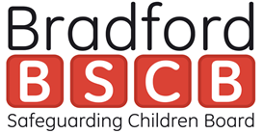

**Bradford Safeguarding Children’s Board**

**Annual Report**

**2018 - 2019**



**Contents Page**

|  |  |
| --- | --- |
| **Chair’s foreword** | **Page 03** |
| **Executive Summary** | **Page 05** |
| **Bradford Safeguarding Children Snapshot** | **Page 09** |
| **Plan on a page** | **Page 13** |
| **Key Partnership Activities** | **Page 14** |
| **LADO - Management of Allegations Against Professionals** | **Page 16** |
| **Learning and Development** | **Page 17** |
| **Child Death Overview Panel (CDOP)** | **Page 18** |
| **Section 175 Schools Audit** | **Page 18** |
| **Voluntary Community Sector (VCS)** | **Page 19** |
| **Collaboration** | **Page 19** |
| **Appendix 1 - Funding** | **Page 22** |
| **Appendix 2 - Board Attendance** | **Page 23** |

**Forward from the Independent Chair – Jane Booth**

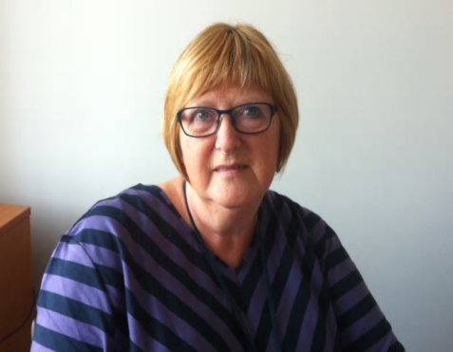

It is my pleasure to introduce this annual report. It covers the financial year from April 2018 to March 2019, a period when the Chair of Board was David Niven. Thanks are due to David, who stood down from this role in March 2019, for his work in supporting the Board.

The population in Bradford is enriched by its diversity. It also has a comparatively large proportion of the population who are under 18. This offers opportunities but also provides challenges in terms of safeguarding. Levels of deprivation are also comparatively high.

The vast majority of children and young people live in caring and supportive families. They thrive in this environment and complete their childhood without experiencing abuse or neglect. However, all children need to be protected from harm and the risks extend beyond their home and family relationships into the world outside where on-line risks continue to become more sophisticated and exploitation either sexual or via gangs are areas of risk that need to be addressed.

It can be seen as a cliché to say that safeguarding is everyone’s business but it is none-the-less true, and we all need to play our part, as parents, educators or in other professional or voluntary roles. .

During 2018-19 Ofsted inspected Bradford Council Children’s Services and found them to be inadequate.  Other members of the Board have said that they were aware of practice deficits and did seek to draw attention to them.  Their view is that these were not sufficiently listened to. A challenge for us for the future is to ensure we recognise that a failure of a significant part of the system is in essence a failure for the whole system and that it is through sharing the problems and working together on them that we are most likely to see progress.  To this end, an independently chaired Improvement Board has been established, with multi-agency representation, and all agencies have committed to being partners in the improvement process.

Following on from the inspection we have seen big changes in the nature and volume of service support for children and their families. Children Social Care have seen big increases in contacts, referrals and child protection investigations. There have been increases in the number of children being supported on a Child Protection Plan and needing to be looked after by the council (in care). While numbers have increased, analysis shows these to still be lower than similar areas and this may be because agencies have become more focussed on need rather than an actual increase in the numbers of children needing support.

Compared with other areas, there are more children on a child protection plan for reasons of emotional abuse and physical abuse than the national average and fewer as a result of Neglect and sexual abuse. More work needs to be done to ensure the need for support is recognised where children are subject of neglect.

The legal frameworks for multi-agency working to safeguard children changed in 2018-19 with new arrangements being established to replace the Bradford Safeguarding Children Board – now established as The Bradford Partnership. I am looking forward to seeing the Partnership develop and an additional degree of challenge is built into the new arrangements.

Work to safeguard children and support them and their families requires skill and commitment. Although it is early days for me in the role of Chair and Scrutineer, it is clear to me that professionals and volunteers in all agencies seek to provide a high quality service, often in difficult circumstances and with shrinking resources and to them I want to give my thanks.

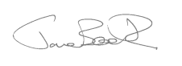

**Executive Summary**

Bradford continues to be enriched by its diversity with a comparatively large proportion of the population (26%) under the age of 18. Partners recognise that all children need to be protected from harm and risk and this is extended beyond their home and family relationships. There is a greater understanding of the risks from more sophisticated methods of exploitation including the on-going challenges around on-line exploitation.

Safeguarding data highlighted that there were over 33000 contacts to Childrens Social Care in 2018-19. This led to over 8000 referrals, 1200 higher than the previous year. Over 4,400 children were the subject of child protection investigations, up a 1000. Over 1,100 children were subject of an Initial Child Protection Case Conference, which was an increase of 566. Finally in March 2019, there were 867 children subject to a Child Protection Plan, an increase of nearly 300 from the previous year. In all these cases there is multi-agency working and providing timely and effective services can be a significant challenge.

In October 2018, Bradford Council Children’s Services were graded inadequate by Ofsted. In support of the Local Authority, the Bradford Safeguarding Children Board (BSCB), now the Bradford Partnership (TBP), continues to play its part in coordinating multi-agency work as part of the Children Services Improvement Plan. This has ranged from oversight, scrutiny and challenge of some agencies to the development of multi-agency policies and procedures, linked training, and also communication across all partners. The partnership conducted 3 multi agency challenge panels in 2018/19 and future panels will continue to support the improvement activity. Partners also contributed to the development of a neglect strategy and toolkit and initial work began on the Threshold and Referral protocols.

Partners continued to promote learning and during the year we published 2 lessons learnt reviews and also worked with another Local Authority on a Serious Case Review, which has yet to be published. Learning informed the themes for the multi-agency audits and also led to a revision of the pre-birth assessment policy. .

Multi-agency training continues to be delivered across a wide variety of topics using various methods of delivery. The training programme included a total of 1738 places and 2580 learners registered for e-learning. The seventh Annual Safeguarding Week was a resounding success with over 60 events. This year also marked the introduction of learning events across the Strategic Boards including the Community Safety Partnership and the Bradford Safeguarding Adults Board which highlighted learning from Serious Case Reviews and Domestic Homicide Reviews.

During the year, in line with other Local Authorities, the BSCB formulated plans to establish new arrangements to come into force during the 2019/2020 period. Working Together 2018 outlined the guidance for safeguarding arrangements and in September 2019 ”The Bradford Partnership – Working Together to Safeguard Children” was formed. The Business Units from the BSCB and the Safeguarding Adults Board combined, improving synergy and consistency of approach. The new structure and plan on a page reflects the changes to the partnership arrangements, both the structure for 2018/19 and the structure supporting the new arrangements are shown below.

Bradford continues to develop collaborative work with other Strategic Boards and amongst the sub-groups. The Risk and Vulnerabilities sub-groups now includes all complex safeguarding themes, linking with the West Yorkshire group. The Communications and Engagement Group continues to increase its membership and influence and expertise to raise awareness and support for professionals and communities.

The annual safeguarding partner self assessment audit process was reviewed and the Schools audit was undertaken. A low return of the schools audit led to a review of the audit tool. Analysis identified a number of strengths including vetting and appointment of safeguarding leads, and the audits also identified areas for improvements including delivery of Relationship and Sex Education.

During the year the Local Authority Designated Officer dealt with 146 referrals, a slight decrease; however there was an increase of nearly 50% in enquiries at just over 500. The main source of management referrals continues to come from Education and Children’s Social Care.

The Child Death Overview Panel reviewed 50 deaths, including 30 deaths that occurred during the year. Of these, 74% were expected with 81% having modifiable factors. South Asian children continue to be overrepresented in the % of deaths mainly due to genetic conditions.

The Board and its sub-groups have met regularly and agency attendance rates at the main Board can be found at Appendix 2 below.



**Mark Griffin**

Manager - Bradford Safeguarding Partnership Business Team

**2018-19 Structure**

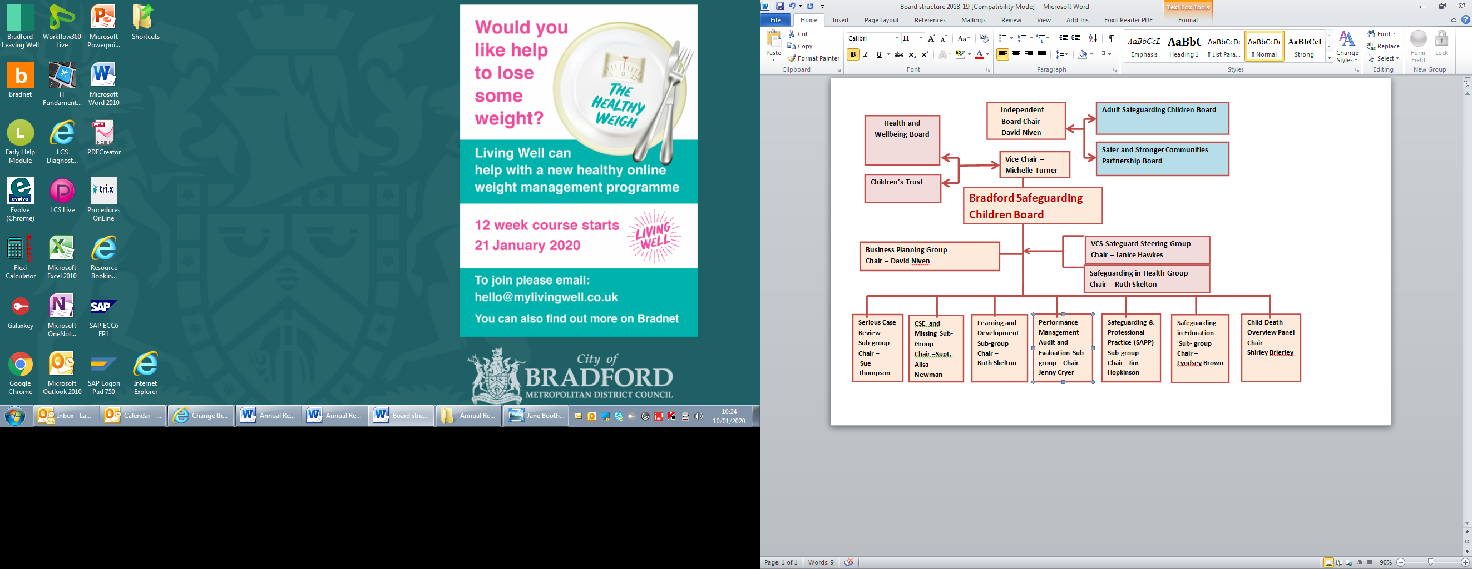

**Revised Structure from September 2019**

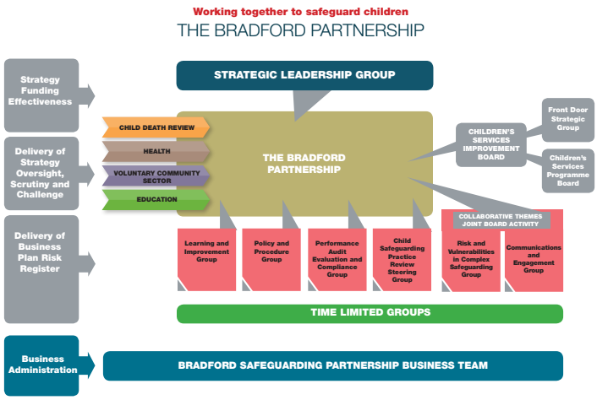

**What do we know about the health and well-being of children in Bradford?**

**If Bradford were a village with 100 children ……….**

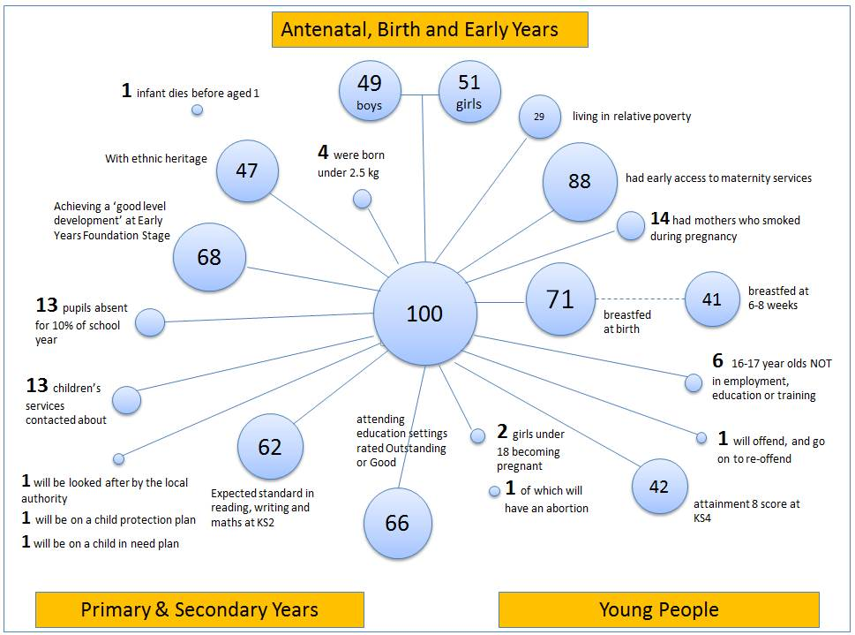

**What do we know about vulnerable children in Bradford?**

There are approximately **140,000** children and young people **under 18** in the Bradford District. This makes up **26%** of total population. This provides both opportunities and challenges.

In **2018/19** there were:

* **29%** of children living in poverty
* **Both child and infant mortality are high, with a value of 5.7 and 15.2 respectively, against National figures of 3.9 and 11.2**
* **Vaccination rates are comparatively high**
* **Tooth decay is comparatively high**
* **5,416** children were defined as **“in need”** at 31 March 2019
* **9%** of children in need were children with a **disability**
* **882** children reported **missing from home**, 278 going missing on more than one occasion.
* **180** of children going **missing** were **looked after** (previously referred to as “in care”. This figure includes some children for whom the responsible authority is not Bradford Council as they are placed away from their home area.
* **33,406** contacts about children’s welfare were received by Children’s Social Care
* **8,863** of **contacts resulted in referrals** for a service (1,246 higher than last year). This was a rate of 615 per 10,000 children which was lower than the Statistical Neighbour (SN) rate of 678.
* **99%** of **referrals** went on to further action (97% last year)
* **21%** were re-referrals (19% last year)
* **11,177 assessments** were completed by Children’s Social Care (increase of 433 on last year)
* **88%** of **assessments** met the statutory requirement of authorisation within 45 working days of referral date
* **4,427** **children** were the subject of **child protection investigations** (1,029 higher than last year). This is a rate of 305 per 10,000 children, higher than the SN rate of 227.
* **27%** of child protection investigations resulted in an **Initial Child Protection Case Conference** (higher than the 18% in the previous year). This is a lower proportion compared to SN and national average of 40%.
* **1,178** children were subject of **Initial Child Protection Case Conferences** (increase of 566 children). This was a rate of 87 per 10,000 compared to 84 for SN.
* **867 children** were subject of a **Child Protection Plan** as of March 2019 (an increase of 297 children since 31 March 2018). This is a rate of 61 per 10,000 children, higher than the SN rate of 56. Of these:
  + 56% were for Emotional Abuse compared to our SN average of 41%)
  + 23% for Neglect (SN average of 49%)
  + 16% for Physical Abuse (SN average was 6%)
  + 5% for Sexual Abuse (SN average was 4%)
* **253** children & young people identified as **at risk of CSE were open cases** to the CSE Hub (end March 2019). 25 were considered to be at High Risk, 69 were considered Medium Risk and 121 were Low Risk
* **1,163** children & young people were **looked after** as of 31 March 2019 (increase of 176 children). This is a rate of 70 per 10,000 which was lower than SN (84).
* **5,462** cases were **open to Children’s Social Care** at 31 March 2019

**What do we know about the quality of services supporting children and families in Bradford?**

The Ofsted Inspection published on 29th October 2018 included a judgement that the Council’s Children’s Social Care services were failing to adequately meet the needs of children and families in Bradford. A multi-agency Improvement Board, independently chaired and reporting to the Department for Education (DfE) was established. Ofsted will make periodic monitoring visits during the course of the improvement programme and a further full inspection will follow in due course.

In common with many other areas, the impact of this judgement prompted significant change. New management arrangements were put in place and improvement activity commenced. Such a significant programme of change is acknowledged to generally take up two years to show sustainable and consistent improvement, requiring the development of new cultures, policies and procedures. These things are all underway.

A number of the partner agencies were subject of their own inspections and reviews during the 2018/19 period. Some key findings are outlined below.

Ofsted regularly inspects Children’s Homes. Bradford Council runs 11 Children’s Homes and during the 2018 / 2019 inspection year Ofsted made the following judgements across the children’s homes inspected.

|  |  |  |
| --- | --- | --- |
| **Children’s Homes Inspection Outcomes**  **2018 - 2019** | | |
| **The Overall Experiences and Progress of Children and Young People Living in The Home** | **How Well Children and Young People are Helped and Protected** | **The Impact and Effectiveness of Leaders and Managers** |
| **Inadequate = 0%**  **RI = 45%**  **Good = 55%**  **Outstanding = 0%** | **Inadequate = 0 %**  **RI = 27%**  **Good = 73%**  **Outstanding = 0%** | **Inadequate = 9 %**  **RI = 18 %**  **Good = 64%**  **Outstanding = 9%** |

Comparing the inspection results for the homes to their 2017/18 inspections two homes that were previously graded as “Outstanding” were now graded as “Good”, four that were “Good” in 2017/18 were assessed as “Requiring Improvement”, three maintained their “Good” grading, while one remained as “Requiring Improvement” and one was a new home not previously assessed and this was graded as “Good”. The local authority undertook some additional work with Children’s Homes and the initial indications are that overall the gradings will be improved in the Inspection period 2019/2020.

Between 25th February 2019 and 1st March 2019 the Care Quality Commission (CQC) conducted an inspection of “Children Looked After and Safeguarding – The role of health services in Bradford”. While this report was not published until 1st June 2019 it does cover the period of this report. The review considered the work of Airedale Foundation Trust, Bradford Teaching Hospitals Trust, Bradford District Care Foundation Trust, Locala, Change Grow Live and the Bridge Project. It also reviewed the three District Clinical Commissioning Groups, Airedale Wharfedale and Craven, Bradford City and Bradford District. The focus of the review was on the experience of looked after children and children and their families who receive safeguarding services. While there was a recognition in the report that there were many strengths within the collective health services across all the agencies involved, a total of 59 recommendations were received from the report and a District wide action plan to address these was formulated for progress during 2019/2020. A number of the recommendations had already been addressed prior to the publication of the report.

The full report can be found at [Review of health services for Children Looked After and Safeguarding in Bradford](https://www.cqc.org.uk/sites/default/files/20190603_clas_bradford_final_report.pdf)

Mental Health Services for Children and Young People in the District are commissioned by the three Clinical Commissioning Groups (CCGs). A comparison of spending and waiting times between April 2018 and March 2019 across England indicated the below for children and young people in the Bradford District. There are significant challenges nationally with mental health services for children and young people and Bradford District is no exception to this. While Airedale, Wharfedale and Craven CCG and Bradford District CCG are generally in the lower middle of assessed services across England, Bradford City is closer to the bottom 20% in relation to this. In terms of average wait times all three CCGs are above the average for England and lower than the England average for mental health spending per child or young person.

|  |  |  |  |  |  |  |  |
| --- | --- | --- | --- | --- | --- | --- | --- |
| **Clinical Commissioning Group (CCG)** | **CCG overall score (5 = bottom 20% in England on all indicators; 25 = top 20%)** | **5 CCG Budget spent on Child and Young Person (CYP) Mental Health (MH)** | **MH spend per CYP** | **MH spend (↑) or down (↓) from 2017/18** | **% of CYP in contact with MH services** | **Average wait time for MH services (days)** | **5 CYP whose referral closed before assessment** |
| **England** |  | 0.92% | 59 | ↑ | 3.36% | 53 | 34% |
| **Airedale, Wharfedale and Craven CCG** | 12 | 0.85% | 53 | ↑ | 2.34% | 67 | 32% |
| **Bradford City CCG** | 6 | 0.77% | 43 | ↓ | 1.78% | 87 | 45% |
| **Bradford District CCG** | 11 | 0.99% | 49 | ↑ | 2.23% | 90 | 35% |

**Strategic Plan on a Page 2019-2021**

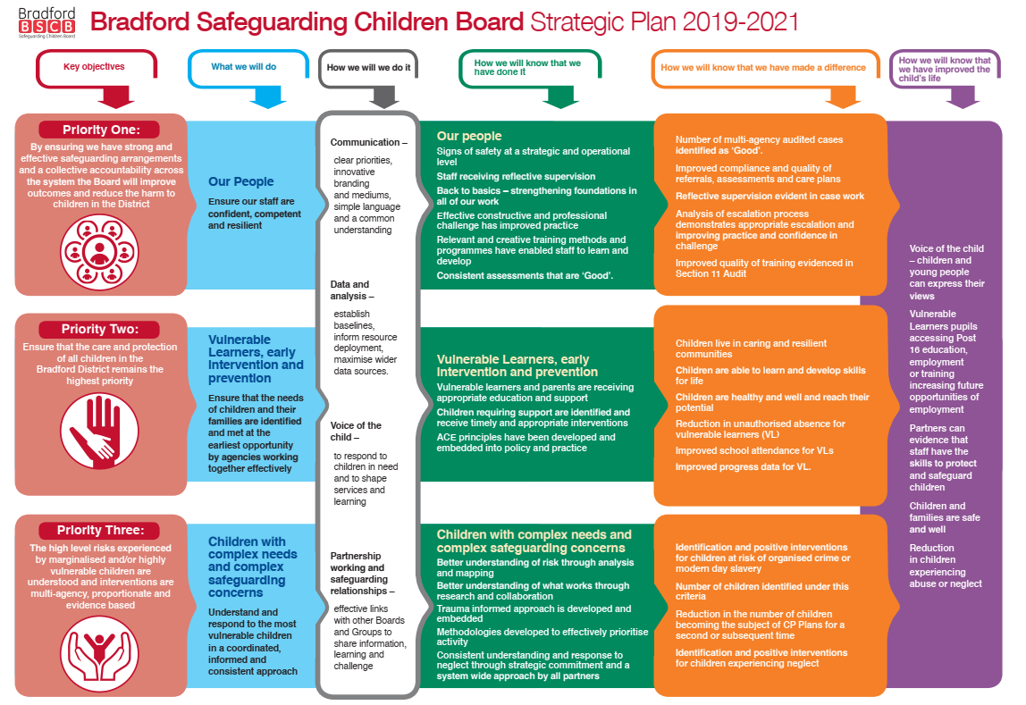

**Key Partnership Activities**

**Working Together**

Following changes brought about by government legislation the BSCB ceased to exist in September 2019 and was replaced by new arrangements – “The Bradford Partnership – Working Together to Safeguard Children”. This report reflects on the activity of the BSCB from Aril 2018 up to end of March 2019 and activity in the first half of 2019/20 will be included in the annual report of the new partnership.

The year has seen extensive work to plan for these changes alongside new structures and staffing arrangements. The Business Units for the previous BSCB and BSAB have been combined as a single Unit which has improved the synergy between the two partnerships and allows a greater consistency of approach, efficiencies of working, sharing of good practice and increased resilience throughout all functions of the Business Unit. This is now known as the Bradford Safeguarding Partnership Business Team.

In November 2018 Children’s Services in Bradford were graded as inadequate following an inspection by OFSTED. As well as the activities undertaken by the Local Authority to address the issues that were highlighted in the report, BSCB has coordinated multi-agency work to support the work of the Children’s Services Improvement Plan. The relationship between the BSCB and the Improvement Board involves a degree of mutual challenge.

The BSCB is active in:

* Providing scrutiny and challenge to partner agencies and the Improvement Board;
* Undertaking work around multi-agency policies and multi-agency training where required through existing sub-groups or focussed task and finish groups;
* Will report progress and assurance into the Improvement Board on a quarterly basis;
* Challenging progress on delivery of the Improvement Board Action Plan through membership of the Improvement Board;
* Acting as a route for communication on progress to enable partners to cascade internally
* Highlighting other concerns, not identified in the Ofsted findings, emerging from BSCB QA activity or partnership working
* Providing oversight and scrutiny for long term sustained improvements through the BSCB delivery plan and risk register.

This work will continue for the duration of the improvement plan for the authority.

**Learning from the past to improve practice**

Serious Case Reviews and Learning Lesson Reviews - During this period two Learning Lesson Reviews (LLRs), “Alice” and “Sameer” were published. In addition a Serious Case Review (SCR) was undertaken with another local authority regarding a child who had moved from Bradford to their authority where a serious incident happened. The review is yet to be published but learning themes have already been identified and action progressed. A number of the areas identified were linked to actions within the Ofsted improvement plan and subject of ongoing improvement work.

To support the multi-agency responses to these reviews key learning was identified and shared with practitioners within Bradford.

[SCR - Sameer](https://www.saferbradford.co.uk/learning-resources/resources/#collapse16)

[SCR - Alice](https://www.saferbradford.co.uk/learning-resources/resources/#collapse14)

Partners undertook work around issues raised in reviews including learning events. All partners and sub-groups recognised the value of the learning and improvement framework and the methodology was taken forward.

In the case of “Alice”, this led to a revision of the policy on pre-birth assessments which was completed and rolled out to practitioners across the District.

**Performance and challenge**

The SCR sub group were able to identify areas for consideration of audit and challenge. During the year audits were undertaken within the following themes:

Children Disclosing Abuse - held in April 2018

The BSCB Case Review Sub-Group commissioned this audit as part of the wider learning from the recent ‘Sameer’ Learning Lessons Review where a child disclosed abuse but e response did not reflect best practice.

This audit identified good evidence of partnership working once risk is identified and also good communication between agencies in the cases audited.  The over-reliance on medical opinion, which was a feature of the Sameer case, was also re-enforced within the cases looked at in this audit as was lack of professional curiosity. Training content has been reviewed to ensure that these themes are appropriately covered in multi-agency training.

Child sexual exploitation, children associated with gangs and at risk of exploitation, and children missing from home, care or education – October 2018

This theme was chosen as it was the Joint Targeted Area Inspection (JTAI) theme focus at the time.  The panel found good information sharing between agencies evidenced in the cases; that the CSE Hub “know their cases well” and follow up on one of the cases has led to the development of the policy for ‘Exceptional Cases Meeting’.  The panel agreed that agencies need to do more to ensure to ensure professionals have access to appropriate level of supervision and that supervision should be reflective.  Reflective supervision was to be further audited within the Section 11 Audit. Three of the four cases reviewed required further remedial action by CSC which was completed.

Children in Care – February 2019

This theme was chosen as it was deemed an area of focus for Ofsted on their next visit to Bradford.  This audit found good Social Worker relationships in all the cases.  Strong partnership working was evident as well as good levels of information sharing.  Inconsistent formal supervision of staff was again highlighted as an issue and this was covered in the Ofsted Improvement Plan.  Loneliness in care leavers was identified as a current issue by the Leaving Care Service who were considering options to tackle this.

The audits supported the pre Ofsted work undertaken by the Local Authority and partners.

The audit tool used for the annual audit of agencies’ safeguarding responsibilities (Section 11 audit), policy and procedures was reviewed, based on learning from the SCR sub group, and was adapted to include questions on supervision. Similar to the previous panel three of the four cases reviewed required further remedial action by CSC which was completed.

**Other Multi-agency work in 2018/19**

Neglect – A multi-agency working group developed a strategy and toolkit to assist professionals in the identification and responses to neglect. Training was reviewed to ensure practitioners were up to date on current practices

Threshold Document and Referral form – Initial work was started on reviewing the threshold document and multi-agency referral form used by agencies in the district. Working groups of professionals from across the district attended workshops in March 2019 to look at alternative documents and suggesting an alternative for use in the District. This work continued in 2019 and the new documents were issued in September 2019.

**LADO - Management of Allegations Against Professionals**

The appointment of a Designated Manager for allegations management is a requirement under Working Together 2018, (para4, p58). The function of the Designated Officer has been based in the Local Authority Children’s Safeguarding and Reviewing Unit since 2006.

In the financial year 2018/19 the Local Authority Designated Officer (LADO) service dealt with 146 referrals which is a slight fall in comparison to the 155 in 2017/18. This was despite an increase in the number of enquiries to the service with a higher number not reaching the threshold for a referral. There were 502 such enquires this year an increase of 48.08% from the last financial year.

In all of these cases work was undertaken and advice offered by the Designated Officer to assist the situation. The largest number of allegations management referrals came from the Education and Children’s Social Care. This has been the case for the past 5 years, which is to be expected given the size of the organisation and the numbers of staff working directly with children in these organisations.

The most prevalent category for referral is alleged physical abuse, with 74 referrals in the past year which making up 50% of the total. The next highest category is sexual abuse with 20 referrals or 15% of the total. Neglect referrals were up very slightly and were 7% of the total. There has been small decrease in the respect of emotional abuse of which has there were 5 referrals 4% of the total.

**Learning and Development**

The BCSB continues to provide a comprehensive multi-agency training programme, working closely with colleagues from the Safeguarding Adult Board and Safer and Stronger Communities Partnership Board (CSP).

* The multi - agency annual training programme included a total of 1738 places
  + 789 places provided on the annual training plan courses;
  + 949 places provided on additional learning and development events; including practice forum, briefings, local and regional events. This included a successful Yorkshire and Humber Multi agency Trainers (YHMAST) conference Safeguarding Children in the Digital World which was hosted in Bradford with Jim Gamble as keynote speaker.

**Online - E learning** - there were a total of 2580 learners registered for e-learning courses, across a range of topics.

**Safeguarding Week**

Bradford District Partnerships were proud to work together on their seventh annual multi-agency Safeguarding Week. “Safeguarding - It’s Everybody’s Business” was once again the focus of a fantastic range of learning and development opportunities.

Safeguarding Week 2018 was held in the summer this year for the first time resulting in a shorter time frame to do all the planning and preparation. However there were still over 60 organised events being hosted across the District for professionals and over 20 events for the public and parents based in the community.

Safeguarding Week showcases the partnership working amongst the Safeguarding Children, Safeguarding Adults and Domestic Abuse and Sexual Violence Boards including their partners, services, young people and service users who also got involved, organised and delivered events throughout the week.

There was an increased focus on getting safeguarding messages to the public through events hosted in a large supermarket and in faith settings as well as numerous sessions held in local schools across the district for parents.

As in previous years, all the partnerships across West Yorkshire joined in and held Safeguarding Week at the same time. The communications team from the West Yorkshire Police and the Police and Crime Commissioner worked with each area in the district to have a shared approach and key message.

The five West Yorkshire LSCB’s hosted a Children’s Vulnerability Symposium for over 150 attendees, with a keynote speech from Professor Nick Frost. The symposium was supported by subject experts covering a range of vulnerabilities and practitioners from across the whole of West Yorkshire were able to share expertise and learn together.

The programme of events for the week was varied and covered many different topics. There were a range of types of events from conferences with 100 plus people attending to interactive workshops of 15 – 20 people.

**Child Death Overview Panel (CDOP)**

The Child Death Overview Panel (CDOP) reviews the deaths of all children under 18 years who are resident in the district via a multi-agency panel using standard processes outlined in Working Together 2015. Child Death Review, Statutory and Operational Guidance 2018 outlines the new child death review process and CDOP has been embedded into the new process.

CDOP aims to understand why children die, identify potentially modifiable factors and use the findings to make recommendations across networks and organisations to reduce the risk of similar deaths in the future.

In 2018/19 (1st April 2018 – 31st March 2019) Bradford District CDOP reviewed 50 child deaths; these reviews included 30 deaths that occurred in 2018/19, 19 deaths that occurred in 2017/18, and one death that occurred in 2016/17. Overall, 88% of deaths were reviewed within 12 months.

Of all deaths reviewed in 2018/19 74% were expected with 26% unexpected. Just 18% of all deaths reviewed were considered to have modifiable factors, with 81% not modifiable.

There was an equal split seen in the count of male and female child deaths. Neonatal deaths (deaths within 28 days of life) accounted for the largest proportion of all deaths, 46%, followed by those aged 5 to 13 years of age. South Asian children continue to be over–represented in the % of deaths; mainly due to genetic conditions and accounted for 56% of all child deaths reviewed. Just over a third of deaths occurred in children of white British ethnicity

Overall infant mortality rates have reduced significantly over the 10 years but are now plateauing in recent years; child mortality has reduced but to a much lesser extent and both remain higher than regional and national rates.

**Section 175 Schools Safeguarding audit**

Schools were again asked to undertake a self assessment of their safeguarding policies, procedures and training via an online assessment tool circulated by the Education Safeguarding Team of the Local Authority. Completion rates were much lower than anticipated (53% across the schools community) which lead to a review of the tool with schools and identified issues have been amended. It is hoped that return rates will improve as a result of this extra work.

An analysis of the returns received from schools identified areas both of strength and challenge.

In terms of strengths, these included assurance about the vetting of employees in regular contact with children, appropriate appointment of safeguarding leads and deputies within school, appropriate procedures for using images of children in publications etc., appropriate management of attendance and robust arrangements for handing over pupils at the start and end of the day.

Challenges identified by some schools were around the delivery of relationships and sex education (RSE), which becomes compulsory in September 2020, identifying a nominated Governor for Children Looked After (CLA) by the Local Authority, identification of an appropriate mental health champion, online safety training for parents and children within the Special Educational Needs or Disabilities (SEND) group, and risk assessment of staff working in isolation for periods of time or outside school premises. All these were addressed by support and training organised by the Educational Safeguarding Team.

**Voluntary Community Sector (VCS**)

The voluntary sector continued to support safeguarding through a wide range of input including:

* delivering specialist services to vulnerable children;
* advocating for children and young people who have been harmed or at risk of harm;
* providing activities that keep young people safe and reduce their risk of exploitation;
* providing activities and support that meets needs of particular communities and young people.

Strategically the sector responded to changes to prevention and early help and the improvement journey and provided appropriate challenge and support to these processes. The VCS safeguarding steering group continued to ensure the VCS had access to training and information and in particular ran a successful peer learning event on the Section 11 audit tool.

**Collaboration**

During this year, and in preparation for the new arrangements in 2019, the BSCB sought to strengthen the joint working with other Board and Partnership groups within the District. It was identified that there were opportunities for closer working relationships with these Boards and that specific work streams were better addressed by joint sub-groups working together.

**Communication and Engagement.**

Building upon the excellent work in the past by the BSAB there is now a Communications and Engagement Group that has been extended to also include representation from the Community Safety Partnership and the BSCB. This group is a mix of safeguarding experts as well as media experts, including a member of the Voice Group, representation from the Voluntary and Community Sector and also a Social Media apprentice. The aims of the group are to provide practitioners, parents, carers’ children and communities with proactive, innovative and consistent approach to communications and the group have developed a communication strategy to support these aims. The BSAB has continues to communicate through a variety of mediums including twitter and other social media platforms but also recognises that other mediums are necessary for other demographical groups.

The BSAB held a successful safeguarding conference in June 2018 that including raising awareness and of safeguarding by showing a real safeguarding story, the event also focused on supporting people to understand what safeguarding means to them and reflecting and developing the key priorities for the board

The BSAB held a development day with key partners to ensure a collaborative approach and shared vision and priorities and also conducted and on line consultation and a public engagement event held to ensure adults with care and support needs and their carers had a say in what they believe were the key priorities for the board. The consultation received over 250 responses from people, professionals and organisations.

**Risk and Vulnerabilities in Complex Safeguarding Group.**

Over a number of years Bradford has benefited from an established and experienced Child Sexual Exploitation and Missing Sub-Group within the Childrens Safeguarding arrangements. The group has extended its remit to coordinate activity around a number of themes, in raising awareness and understanding. The group is now known as Risk and Vulnerabilities in Complex Safeguarding. This group acts as a coordinating group to oversee and coordinate activity by partners in response to varied safeguarding themes. These include existing areas such as Child Sexual Exploitation and Missing, Modern Day Slavery, Prevent and also new and emerging threats such as Criminal Exploitation, Organised Crime and County Lives. Senior leaders recognised the impact of these threats is not just on children but vulnerable adults can also be at risk of exploitation. To develop thinking and increase collaborative opportunities the group now includes representation from a number of partners and also across the Childrens and Adult safeguarding Boards as well as the Community Safety Partnership. The group has developed a Strategic Response to this work.

**Pan West Yorkshire activities** – The BSCB has been an active member of the West Yorkshire wide Risk and Vulnerabilities Group organised by the Police and Crime Commissioner’s office. This has looked at coordinated activities and responses to Child Vulnerability across the five Local Authorities in West Yorkshire and enabled the sharing of good practices and ideas across the County.

**Joint SCR/Domestic Homicide Review (DHR) learning event** - Delivered jointly by the Bradford Community Safety Partnership (CSP) and BSCB multi agency trainers this event was developed to bring together themes across different review types. The workshop was delivered to members of senior leaderships across the partnership and looked at:

* Why we undertake reviews
* An overview of ones that have been undertaken
* Common themes
* Our role as employers
* How colleagues can support each other
* Access support.

This workshop proved to be really successful and following positive feedback it was replicated twice throughout the year.

**Appendix 1 - Funding**

The BSCB staffing and Operational Budget is provided by a pooled budget totalling £360,040. The contributions to the pooled budget for the BSCB in 2018-19 were as follows:

* Bradford Council Children’s Services - £179,100
* Health - £158,350
* Police - £17,350
* Community Rehabilitation Company - £2,345
* National Probation Service - £2,345
* Cafcass - £550
* Miscellaneous Income - £5302

The BSCB budget was overspent by £20,829 which resulted from increased staffing costs as well as costs associated with the CDOP process and increased costs of the Independent Chair. These were partly offset by savings in other areas.

**Appendix 2 - Board Attendance**

During 2018/19 there were four meetings of the Bradford Safeguarding Children Board, in June, September and December 2018 and March 2019. Attendance of the different agencies was as follows.

Key:

CSC – Children’s Social Care

CCG – Clinical Commissioning Groups

ANHSFT – Airedale NHS Foundation Trust

BDCFT – Bradford District Care Trust

BTHFT – Bradford District Teaching Hospitals Foundation Trust

Cafcass – Children & Family Court Advisory and Support Service

NPS – National Probation Service

YOT – Youth Offending Team

WYCRC – West Yorkshire Community Rehabilitation Company

VCS – Voluntary Community Sector

NSPCC – National Society for the Prevention of Cruelty to Children

|  |  |  |  |  |  |
| --- | --- | --- | --- | --- | --- |
|  | **27/6/2018** | **26/9/2018** | **13/12/2018** | **26/3/2019** | **% attended** |
| **CSC** | Y | N | Y | Y | 75 |
| **Police** | Y | Y | Y | Y | 100 |
| **CCG** | Y | Y | Y | Y | 100 |
| **ANHSFT** | Y | Y | Y | Y | 100 |
| **BDCFT** | Y | Y | Y | Y | 100 |
| **BTHFT** | Y | Y | N | Y | 75 |
| **Cafcass** | N | Y | N | Y | 50 |
| **Education** | Y | Y | N | N | 50 |
| **NPS** | Y | Y | Y | Y | 100 |
| **NHS England** | Y | N | N | N | 25 |
| **YOT** | Y | Y | Y | Y | 100 |
| **WYCRC** | N | Y | Y | Y | 75 |
| **Public Health** | N | Y | Y | N | 50 |
| **VCS** | Y | Y | Y | Y | 100 |
| **NSPCC** | N | Y | Y | N | 50 |