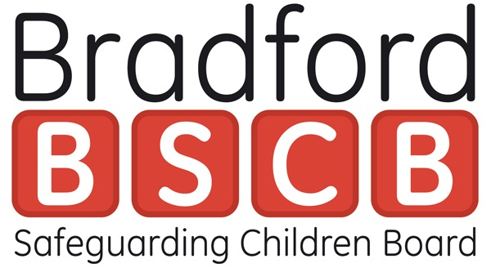

Bradford Safeguarding Children Board strategic response to Child Sexual Exploitation (CSE)

Introduction:
Local Safeguarding Children Boards (LSCB) has the responsibility for ensuring that relevant organisations in the local area co-operate effectively to safeguard and promote the welfare of children. Tackling Child Sexual Exploitation, published in March 2015, set out an ambitious programme of work to address on a national scale some of the failures, brought to light by Professor Alexis Jay, Dame Louise Casey and others.

Within Bradford, partner organisations have decided that Bradford Safeguarding Children Board (BSCB) is the lead strategic body for the development and implementation of the District’s response to CSE. BSCB is required to ensure that the needs of children and young people who have been, or may be, sexually exploited and their families are considered as it:
- Guides the planning and commissioning of services;
- Develops policies and procedures;
- Ensures that appropriate training is in place;
- Communicates and raises awareness; and
- Monitors and evaluates the work that is being done.

This BSCB strategic response sets out the key strands to be addressed in the work to tackle CSE in the Bradford District and this document takes into account the progress made in improving the Districts response to CSE in the 9 Point Strategic Response and previous BSCB “7 Point Strategic Response to CSE” which was agreed in July 2013.
The overall objective remains that the partnership response to CSE is child, young person and victim focused.

These strands describe statutory safeguarding activity to be undertaken by statutory and voluntary sector partners, awareness raising and training activity, and community initiatives informed by specific knowledge of the incidence of CSE in the Bradford District. This Strategic response recognizes the links between children who go missing and CSE and takes cognisance of the Bradford Missing Children Multi-Agency Strategy 2016/18. Taken together, the overall aims of these strands are:
- Identify and understand the nature and scale of CSE
- Prevention, Education and Awareness
- Safeguarding vulnerable people, groups and communities
- Effective leadership and governance
- Disrupt and Prosecute
- Communication, Engagement and Empowerment
Definition of CSE from Government Guidance:

Following on from the definition in 2009, the Government has refreshed and produced the following definition in February 2017.

“Child sexual exploitation is a form of child sexual abuse. It occurs where an individual or group takes advantage of an imbalance of power to coerce, manipulate or deceive a child or young person under the age of 18 into sexual activity (a) in exchange for something the victims needs or wants, and/or (b) for the financial advantage or increased status of the perpetrator or facilitator. The victim may have been sexually exploited even if the sexual activity appears consensual. Child sexual exploitation does not always involve physical contact; it can also occur through the use of technology.”

The plan will focus upon the following groups in all aspects
- Children and young people
- Communities
- On-line activity
- Parents and carers
- Professionals and people involved with children and young people
All activity will consider the voice of the child in responding to immediate needs and how the voice of the child is used to inform planning and designing of services.
- Identify and understand the nature and scale of CSE
Bradford is committed to understanding the local threat risk and harm to allow a proportionate and appropriate response to CSE.
- Maintain strategic assessments, problem profiles and develop a joint data set
- Vulnerable people and groups
- Victims – recognising gender and age
- Locations which can attract vulnerable people and potential perpetrators
- Methods and types of abuse
- Perpetrators including tackling unacceptable attitudes and pre offending behaviour
- Linkage to emerging threats –Missing/Modern Day Slavery, Criminal Exploitation and Organised Crime Groups
- Effective information sharing – including ISA

- Prevention, Education and Awareness
Bradford is committed to raising awareness of CSE among children and young people, parents, carers and potential perpetrators, to prevent incidents / repeat incidents of CSE.
- Working closely with children and young people to understand and response to CSE
- Raising awareness amongst all communities, parents, carers and potential perpetrators
- Training for professionals to enable identification and responding to CSE, recognising the importance of CSE work in all phases of schools, colleges and in alternative educational provision.
- Work with the industry sector and night time economy to raise awareness and develop prevention strategies

- Safeguarding and supporting vulnerable people, groups and communities
Bradford is committed to safeguarding vulnerable children and young people and supporting victims and those professionals who seek to reduce instances of CSE
- Adopting the Journey to Excellence principles
- Support and intervention - timely therapeutic and support services
- Information to advise and access support
- Coordinated services available to work with all groups

- Effective leadership and governance
Bradford is committed to providing strong leadership, effective systems whilst working with partners to tackle CSE. The BSCB remains open in identifying areas for improvement and to encourage change.
- Effective systems around the Front Door/ MASH and CSE processes
- Encourage statutory and non-statutory partners to work together to develop and strengthen our collective safeguarding efforts
- Quality assurance of improved outcomes for children
- Developing best practice and learning
- Multi agency training at all levels – initial contact through to specialist services, leadership teams and those who are able to influence planning and change
- Improving outcomes and reducing harm to young people who are vulnerable to or at risk of exploitation and victims of exploitation

- Disrupt and Prosecute
Bradford is committed to disrupting, arresting and prosecuting Child Sexual Exploitation offenders, ensuring a victim centred approach at all times
- Partnership response
- Collaborative working with law enforcement and criminal justice agencies
- Proactive response to prevent crimes and harm
- Early interventions for potential perpetrators
- Support to victims throughout investigations and proceedings
- Continued partnership response to multi-agency historic investigations into CSE

- Communication, Engagement and Empowerment
Bradford is committed to increasing public confidence and awareness and listening to the views of children, young people and communities to improve the delivery of services.
- Coordinate the delivery of the strategic response to CSE
- Ensure effective internal communications to professionals across the partnership
- Ensure effective external communications to parents, carers and children.
- Maximise on-line and social media opportunities and campaigns
- Raising awareness and understanding amongst all groups
- Empowering and involving communities to develop community resilience
The BSCB Child Sexual Exploitation (CSE) and Missing Children sub group is responsible for ensuring that this Strategic Response is up to date and reflects national and local policy and procedures in respect of CSE. All BSCB action and improvement plans related to CSE and all such individual agency plans must be guided by this Strategic Response.

