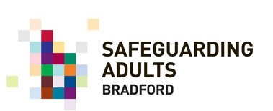
Title: Understanding the Legal Powers of Safeguarding Adults Boards to Request Information for Safeguarding Adult Reviews

Introduction:

Safeguarding Adult Reviews (SARs) are statutory inquiries carried out by Safeguarding Adults Boards (SABs) under Section 44 of the Care Act 2014. A SAR aims to identify learning and make recommendations to improve safeguarding practice and prevent future harm to adults at risk. As part of the SAR process, SABs have legal powers to request information from relevant agencies and organisations. Failure to provide the requested information may hinder the SAR process and could result in the adult being placed at further risk of harm.

Legal Position:

Under Section 44 of the Care Act 2014, SABs have the legal power to request information from any person or organisation they believe holds relevant information to carry out a SAR.

This includes local authorities, health and social care providers, and other relevant agencies. The requested information must be necessary for carrying out the SAR and be treated as confidential.

Consequences of Non-Compliance:

Failure to provide the requested information to SABs may constitute a breach of the legal duty to cooperate under Section 44 of the Care Act 2014, which requires relevant agencies and organisations to cooperate with the SAB the carrying out of a SAR.

A breach of this duty may result in the SAB taking enforcement action against the non-cooperating agency or organisation, including legal proceedings.

Penalties for non-compliance can include fines or other sanctions and may damage the reputation and standing of the non-complying agency or organisation.

Conclusion:

Compliance with the legal duty to cooperate with SABs is essential to ensure that SARs are carried out effectively, that learning is identified, and that safeguarding practice is improved. All relevant agencies and organisations must provide the requested information promptly and comprehensively to enable the SAB to conduct a thorough investigation and promote good safeguarding practices.

Please visit the Safer Bradford website for more details about BSAB and safeguarding adults' review www.saferbradford.co.uk/adults

