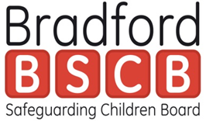
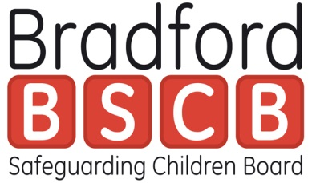
STANDARD | PROGRESS/EVIDENCE
Standard 1
All training is delivered by qualified or appropriately experience/trained tutors

Standard 2
All safeguarding children training is linked to current and evolving local, regional and national standards

Standard 3
The training has clear aims and objectives and meet agreed learning outcomes – and has a positive impact in practice

Standard 4
The course is informed by current research, is evidence based and includes lessons from Serious Case Reviews and local and national policy and practice development

Standard 5
Training materials are clear, accurate, relevant and up-to-date

Standard 6
The training will be delivered by trainers who have knowledge and experience of safeguarding and who have completed Training the Trainers programme/professional equivalent (or have relevant training experience)

Standard 7
Training will be delivered in an environment which is conducive with learning and ensure all appropriate staff are given opportunity to attend

Standard 8
All training creates an ethos that values working collaboratively with others, respect diversity (including culture, race, religion and disability) and promotes equality and appropriate challenge

Standard 9
All training will be evaluated to ensure that standards are being maintained and that it enhances practices in the long and short term
Standard 10
All training places the child at the centre and promotes the importance of understanding the child’s daily life experience

Standard 11
All training encourages evidence of appropriate challenge

Overview

Signed

Print Name:
Date:

