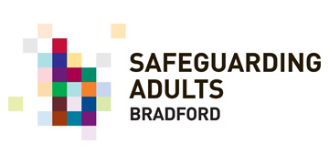

**Safeguarding Voice Group Newsletter**

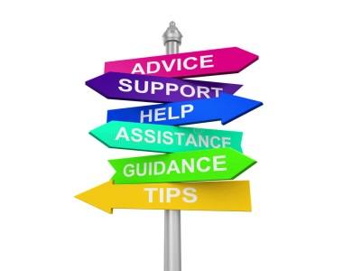

Welcome to the 8th edition of the Safeguarding Voice Newsletter.

* **WE DID IT!** We finally met face-to-face as a group – and it was fantastic to actually see our members in person rather than on a tiny laptop or phone screen! The last time most of us had seen each other was in March 2020!
* We had a display board to celebrate the many things the group had achieved either as a group or individually during the Covid pandemic – and pictures are included later in this newsletter.
* As this was truly a day to celebrate, we had plenty of cake and buns and we found out at the meeting that it was Damian’s birthday – so it was a double celebration!
* We were joined by Lizzie Whewell, who works with the domestic violence team and you can read more about Lizzie later in the newsletter.
* There is still the need to stay vigilant about scams that are currently operating and we will continue to share detail of any emerging scams with group members.
* We had a packed agenda with a number of activities around priorities and the group were even sent away with ‘homework’.





# WE DID IT! WE FINALLY GOT TO MEET FACE-TO-FACE AGAIN

Our first face-to-face meeting since March 2020 was held at ‘The Hub’ which is part of the Fountains Church complex, between the Alhambra and the ice skating rink. The venue itself was lovely and although we had a few teething problems with drop-off points – we will know now for the future. We scheduled a 2-hour meeting as we knew we had lots to talk about as well as a full agenda. It was just fantastic to see everyone and I for one had been so excited about us all getting together. Much cake was eaten as well as having a really lively and productive meeting! It was so nice to have a full meeting where someone didn’t have to say “you’re on mute”!

# LIZZIE WHEWELL



We were joined for the first time by Lizzie Whewell, who works within the Domestic Abuse and Sexual Violence Team. Lizzie advised the group that the team will be launching a new website soon, which is exciting news. This will be an intuitive website allowing information to be accessed in different languages as domestic abuse knows no boundaries. There is a lot of work being undertaken to raise awareness of Domestic Abuse and where to get help and Lizzie is also involved in running focus groups. Lizzie has also been working on real life story films with those who have suffered Domestic Abuse



The day was an extra special event as it was Damian’s Birthday! Happy Birthday!

# TIME TO REFLECT ON WHAT WE’VE ACHIEVED IN THE LAST 2 YEARS!

As this was our first meeting in so very long, we wanted to take time to reflect on what we had achieved as a group and as individual organisations over the last 2 years! We have proved beyond doubt what a positive thinking set of individuals we are, however each lockdown was hard for us all, particularly in the winter months. We had however, compiled a list of the positive things we did to help and support each other through those strange and worrying times and so we thought that we’d turn it into something quite visual for our meeting so that we could celebrate what we did!

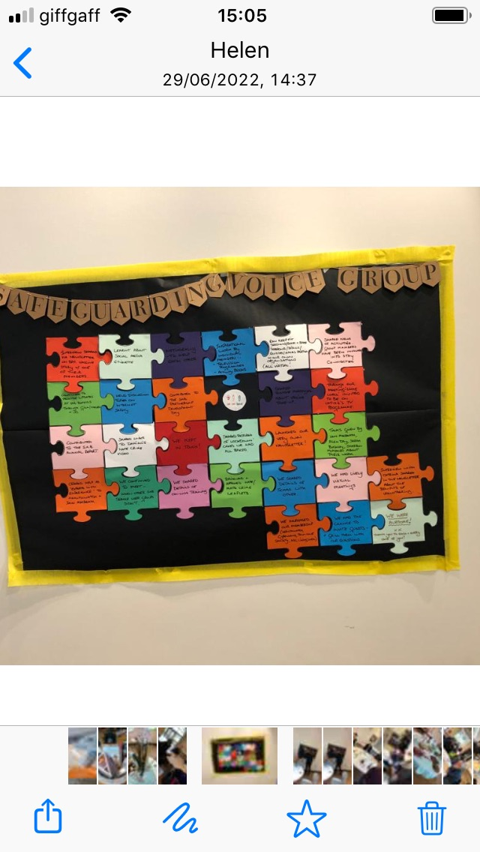

# One of our agenda items was an activity to look at the good, the bad and the ugly of Covid/ Lockdown and how it made is feel. This is what the group said:

**THE GOOD**

Made links with different people in our own and other organisations

Maintaining and extending friends and family relationships

Spending more time with the family

Building on IT skills

Not having to meet people we didn’t like!!

Learnt about Covid and how to do LFTs

Using new Apps like WhatsApp

Learning about social media – and etiquette

No hugs!

**THE BAD**

Supporting each other on-line and by phone

Time to complete all those tasks we never have time to do: decorating, gardening etc.!

Joining virtual book clubs

Walking – exploring local footpaths

Improvement in climate change – less use of fossil fuels

Learning to use Zoom/ Teams

Took part in new ‘virtual’ activities

More time to focus and plan

Learnt

new social skills

Becoming more proficient with emails

Enjoying the fresh air

Loss of freedom

Difficult to understand rules

Misinformation and rumours about the jab and side effects

Social Distancing

Not being able to provide support face-to-face

Couldn’t see the doctor for routine check-ups

Weight gain!

Rules!

Not able to go out!

Mental Health suffered

Loss of Self Confidence

**THE DOWNRIGHTUGLY**

Isolation – especially in winter

Not being able to see family in hospital or at end of life

Not being able to see family and friends

Lonely

**PRIORITY SETTING**

Another piece of work the group did at the meeting was to have a discussion in groups about our **priorities.** There was, as always, some lively discussion – and it was great to be back in a room together as virtual meetings didn’t provide the same opportunity for group discussions.

* **Mental Health**
* **Access to Services and Support**
* **Listening to People’s Views**
* **Health and Wellbeing**
* **Common Understanding**
* **Networking Opportunities**
* **Stronger Links with SAB**
* **Broadening Membership**
* **Making Sure the Voice of the Client is Heard**
* **Review of Cases/Issues Raised**
* **Ensuring People Understand What Safeguarding is**
* **Ensuring People Understand the Roles of Agencies**
* **Making Things Accessible**
* **Scams!**

The priorities that we felt as a group to be really important were:

# C:\Users\hirstjoan\AppData\Local\Microsoft\Windows\INetCache\Content.Outlook\KYGV89GF\safeguarding 6 (002).gif

# Safeguarding Week Stand - Wednesday 22nd June

The group were asked to let Helen or Jo know whether their organisation was planning any events, so that these can be publicised. The group were also asked for their input regarding what work could be planned during this week.

The Safeguarding Voice Group will be having a stand in The Broadway Shopping Centre in Bradford to engage with the public about what safeguarding means to them. We will also take copies of the leaflets that this group have provided feedback on.

# Bradford People First

Bradford People First

We were delighted that a team of six were able to join us at the meeting and it was fantastic to see so many of you!

BPF are have undertaken a piece of work around the BAME community in relation to mental health as with without support individuals can suffer.

They are also developing forums and working groups in order to discuss specific issues and a small group format.

BPF are also doing a pieces of work around climate change and feeling safe’

Damian raised an issue that he is aware of regarding buses not stopping when they see someone in a wheelchair and thinks it may be because they have to lower the ramp. Gill B attends the mobility planning group and asked that Damian email her so that she can raise at the next meeting as they are developing a self-advocacy group.

BPF are now offering employment support and training to L2 in CV skills.

BPF are also having a stand in the Broadway centre during safeguarding week to raise awareness of all the fantastic work they do!

# Keighley and Craven People First

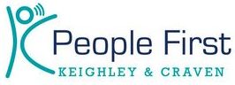

Unfortunately, Keighley and Craven People First were unable to join our meeting, but as always, they have been really busy and we shared details of their forthcoming event ‘Ask the Pharmacist’ which was taking place on the 9th June. This event will let attendees know the many different ways that pharmacists can help the public with health advice and so much more!

# GILL’S UPDATE

Equality Together continue to give welfare advise and also have a thrift shop within Manningham Mills. The Living Well Centre allows individuals to try out beds and equipment and occupational health have a presence three days a week. Gill is also part of the Burley Good Neighbours Group, which amongst other things assists with providing lifts to hospitals for those that need this help

Gill let the group know about a 1-day event on the 4th July which will take place at the Mercure hotel in Bingley. The event is just for those who are living with a disability.

# And more news from the group!

# PETER’S UPDATE

Peter continues his work with the dementia group and they have been putting together memory boxes to allow individuals to take away items like CDs and magazines.

# GULFASINAS UPDATE

Gulfasina attended a really interesting safeguarding conference at the Midland Hotel in Bradford which gave loads of information about scams, keeping safe and abuse.

# LIVING WELL – ‘MENTAL HEALTH FIRST AID’ - TRAINING COURSES



Just a reminder that **Living Well** provides free training course on a range of topics including mental health first aid. For more information and to book please look at the training section of their website:

<https://mylivingwell.co.uk/about-us/mhfa-training-courses>

**YOUR IDEAS PLEASE!**

We also need your ideas on guests that we can invite to future meetings – just let **Jo** or **Helen** know if you have any thoughts about who we can next put under the spotlight.



**WE ALL GOT HOMEWORK!!!**

# SUMMARY

* Words cannot describe how good it was to meet face-to-face ☺
* The Group completed lots of work within the meeting and even had homework to take away!
* We continue to welcome new members to the group, making really important links within our district in order to hear the voice of under-represented groups.
* We continue to seek feedback and ideas from the group to ensure that our voice is considered within BSAB planning and development work.
* The newsletter continues to make waves and is circulated widely

# make decisions - Clip Art LibraryTHE NEXT MONTHS – OUR FUTURE PLANS

* We will spend time at the next meeting looking at the priorities we set in the meeting and look at potential quick wins and longer term planning.

* The Voice Group Newsletter will continue to capture the positive stories about innovative work being done within the group to stay connected
* To undertake work to update the ‘Terms of Reference’ and membership of the Safeguarding Voice Group in conjunction with feedback given (…if we all do our homework!)
* To complete the activity ‘what makes a good friend’ – time was not on our side at this meeting as we had so much catching up to do!
* Researching and sharing innovative ways of contacting/ befriending those who are ‘hard to reach’ (i.e. who are not computer savvy/ unable to use available technology without assistance or don’t have the necessary technology) - for the group itself and in turn, influence or contribute to work being done in the district as a whole.
* Investigate additional training on social media offered by ‘People Can’.
* Additional group work/ circulation of information on keeping people safe, covering:
* Avoiding people preying on the isolated and vulnerable
* How to check that people are safe?
* Podcasts about safeguarding the vulnerable and disabled
* Contact the Mobility Planning Group to invite them to a future meeting

**Safeguarding Voice would like to invite you to our meetings. Come and share how you are working across Bradford to help keep people safe – share with us your good practice! Do you want a genuine service user voice......well we are here to help! For more details email** [**BSAB@bradford.gov.uk**](mailto:BSAB@bradford.gov.uk)

**Do you know of anyone who might benefit from joining our group if so get in touch with Helen or Jo at** [**BSAB@bradford.gov.uk**](mailto:BSAB@bradford.gov.uk)