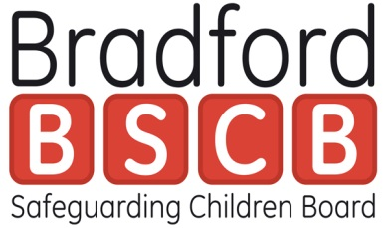
Training and Target Audience Descriptors
It has been agreed that the following simplified descriptors will be used for multi - agency safeguarding learning and development.
These are based on the previous descriptors which were published in “Working together to safeguard Children 2010”.
It is recognised that many of the organisations in the partnership also have requirements in relation to safeguarding children training determined by their own policies and / or through guidance from professional bodies.
This document can be used alongside other learning and development guidance.
The matrix identifies generic levels Basic, Intermediate, Advanced, Specialists with a descriptor summarising the level of responsibility in relation to safeguarding children in the role and some examples. This is not an exhaustive list.
Each organisation / setting can add in any particular requirements for their staff group, e.g. Health Intercollegiate Guidance levels, Education Designated Leads, Early Years Designated Leads
The final column is for each organisation to provide data on their staff groups in each category which will be required for the Section 11 Audit

Julie Evans May 2018

Definition | Target Audience | Examples | Professional Requirements | No of staff  % Compliant
Basic  Individuals new to the area of learning requiring foundation knowledge | Staff in infrequent contact with children, young people. Parents/carers who may become aware of possible abuse or neglect. | GP receptionists, librarians, dental nurses, dental receptionists, community centre staff, recreation assistants
Intermediate  Individuals who have completed the basic level of training and require a higher level and understanding to be competent in their role | Those in regular contact or have a period of intense but irregular contact, with children, young people, parents / carers who may be in a position to identify concerns about maltreatment including those that may arise during the “Early Help Assessment” process. | Housing ,hospital staff, YOT staff and staff in secure settings, police (not in specialist Child protection roles),sports development officers, disability specialists, faith groups, community youth groups, play scheme volunteers, foster carers and child minders, volunteers in similar roles
Advanced  Practitioners who have completed the intermediate level of training and require specialist training or CPD  Advanced | Members of the workforce who work predominately with children, young people, their parents / carers and who could potentially contribute to assessing, planning, intervening and reviewing the needs of a child and parenting capacity where there are safeguarding concerns including the designated lead in any setting.  Also Members of the workforce who have particular responsibilities in relation to undertaking section 47 enquiries in all sectors ,those working with complex cases and social work staff responsible for coordinating assessments of children in need. | Youth and play workers, early years sector ,residential staff, children’s social care, midwives, school nurses, health visitors, sexual health staff, named and designated safeguarding leads in all settings ,probation staff, adult services including mental health, alcohol and drugs , domestic abuse and volunteers in similar roles
Specialist -Managers/Leaders  who require training in relation to their safeguarding role | Operational and senior managers and members of the LSCB | Strategic and Front line managers, practice supervisors, board members

