BRADFORD’S EARLY HELP ASSESSMENT TOOL  An Early Help Assessment when working with children and their families |  |  | 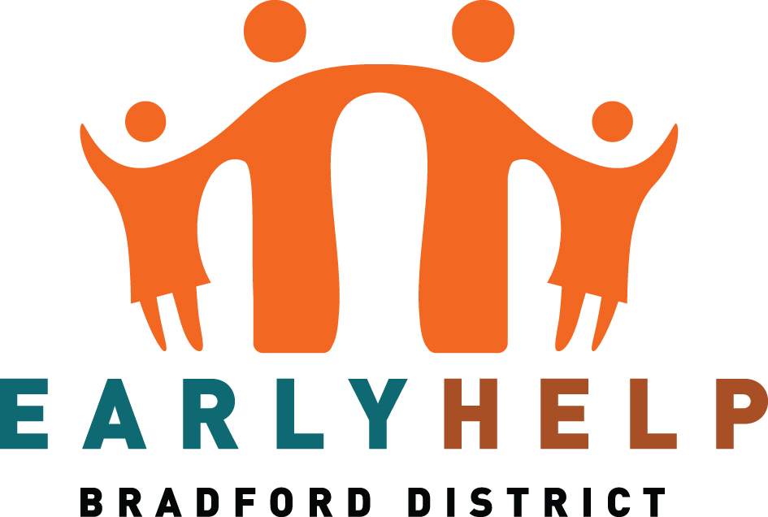
The Agreement
If you would welcome support for your family, then we need your agreement for agencies to co-ordinate any support you may need through sharing information about your family with them. This could include the following agencies: Children’s Specialist Services, Schools, Police, National Probation Service, West Yorkshire Community Rehabilitation Company, Youth Offending Team, Department of Work and Pensions (including contracted work programme providers), Incommunities, Families First Commissioned Services, your GP, Health Visitors, School Nurses, Family Hub, Stronger Families and Bradford Teaching Hospitals NHS Foundation Trust’s Innovation Hub who are undertaking important research about children’s development for Better Start Bradford and Born in Bradford Projects. Access to information is carefully controlled and only approved members of the Innovation Hub Team will be able to identify you whilst keeping your information private and safe so that no information that could identify you or your child will be shared with anyone else.
We collect and process personal and sensitive information in accordance with the General Data Protection Regulation. This information may include details about you/your children’s health including NHS Numbers, education and UPN Numbers, welfare and development, home or family circumstances. We use this information:
- To help us work with you to provide an effective service
- To help us improve services through research and planning
In some cases, information may be shared between agencies without consent; for example, where sharing information might prevent a crime or safeguard the welfare of a child or young person. Even in these circumstances, we will discuss this matter with you. Reasons for this are:
- If it is believed that a child’s/adult’s safety or welfare is at immediate risk
- Where it is required to do so by law because of a criminal activity /drug trafficking offences
- Should you or your child fall ill during contact with the service and relevant information needs to be given to a medical professional
CONSENT FOR INFORMATION STORAGE AND INFORMATION SHARING
The reasons for sharing information have been explained to me. I give my permission for Bradford Council to obtain personal and /or sensitive information about me and my family for the purposes set out above and agree to my information being shared with and for Prevention and Early Help / Families First / Social Work services.
My explicit consent is freely given, fully informed and I understand that it can be withdrawn at any time. I have been given the opportunity to ask any questions in relation to this referral and the information about me that will be shared and that I can request an update at any time. I have the right of access to personal information held about me and my children and can request this by making an application in writing.
This completed form will be retained by Bradford Council. Information will be stored on a secure electronic system and shared with other organisations as appropriate, and only communicated by secure means. It will be destroyed in accordance with data protection principles and Bradford Council retention policy. Read our full Privacy Notice.
If you are the Parent/Carer you are also giving your permission to share personal information about young people (under 16) in your care.
Signed: | Print Name: | Date:

- Person undertaking the assessment
Name | Role / Position |  | Agency / Service |  | Address  (Inc. postcode) and contact number
Signed |  |  |  |  | Date
Date Assessment Started |  | EHA Reference No. |  | Date Assessment Completed

- Some basic details about you and your family – Parent / Carer
Parent / Carer Surname | Parent / Carer First Name | Relationship to child
Date of Birth and NHS no | Ethnicity | Parent/ Carer Gender
Parent / Carer Surname | Parent / Carer First Name | Relationship to child
Date of Birth NHS no | Ethnicity | Parent / Carer Gender
Address (Inc. postcode) |  | Contact Number
Name of family Doctor | Address | Contact number
Name of family Dentist | Address | Contact number

Children and other people at the home address
Surname | First Name |  | DOB | Relationship |  |  | School / Nursery | NHS no | EHCP | Disability | SEN | Ethnicity
 |  |  |  |  |  |  |  |  | Yes / No | Yes /  No | Yes / No
Add new Row |  | Delete last row

Additional Caring Responsibilities
Are you caring for someone else's child? |  |  |  | Yes | No
If the answer is yes, is there an order in place? |  |  |  | Yes | No
What type of Order? | Child Arrangement Order | SGO | Parental Responsibility Order |  |  | N/A

Details of other Parent / Carer / Adult with Parental Responsibility not living at this address
Name |  | D.O.B and NHS no: if known | Address
Will they contribute to the Early Help Assessment |  |  | If no, please explain why
Yes | No

Significant others, including siblings who live at a different address (please provide details of any other people connected to the family who are important in providing a network of support e.g. grandparents, wider family and friends)

Surname |  | First Name |  | Address | Relationship to child | DOB
Add new Row | Delete last row

Other services supporting your family (please use a separate sheet if necessary)
Service |  | Contact Name |  | Contact Number | Which family member is being supported
Add new Row | Delete last row

- Strengths and Needs - this is where we identify what we are worried about and what is working well
Who was present at the assessment
(give names and relationships, including the person undertaking the assessment)

Voice of each Child (please reference any tools used to engage the children e.g. Three Houses, using the child's own words wherever possible. For pre-verbal children, please use this section to record your (or other practitioner's) observations

Please complete the remaining sections to record a summary of your conversation with the family, as well as including information received from the relevant professionals.
HEALTH - General health, outstanding health needs, parent/carer ability to meet these needs
On a scale of 1-10, where 10 is the best situation, how would you rate how well are things going?
1 | 2 | 3 | 4 | 5 | 6 | 7 | 8 | 9 | 10
What is working well (strengths)? |  |  |  |  | What needs to change (goals) and why?

EDUCATION - Nursery, school, college, training, stimulation at home, parent/carer ability to meet these needs
On a scale of 1-10, where 10 is the best situation, how would you rate how well are things going?
1 | 2 | 3 | 4 | 5 | 6 | 7 | 8 | 9 | 10
What is working well (strengths)? |  |  |  |  | What needs to change (goals) and why?

Emotional Development and Wellbeing - Mental health, substance misuse, domestic abuse,
emotional warmth from carer parent / carer ability to meet these
On a scale of 1-10, where 10 is the best situation, how would you rate how well are things going?
1 | 2 | 3 | 4 | 5 | 6 | 7 | 8 | 9 | 10
What is working well (strengths)? |  |  |  |  | What needs to change (goals) and why?

Family and Social Relationships – Parent / carer ability to ensure safety, stability of relationships, anti-social behaviour and crime
On a scale of 1-10, where 10 is the best situation, how would you rate how well are things going?
1 | 2 | 3 | 4 | 5 | 6 | 7 | 8 | 9 | 10
What is working well (strengths)? |  |  |  |  | What needs to change (goals) and why?

Housing, Income and Employment - Including home conditions
On a scale of 1-10, where 10 is the best situation, how would you rate how well are things going?
1 | 2 | 3 | 4 | 5 | 6 | 7 | 8 | 9 | 10
What is working well (strengths)? |  |  |  |  | What needs to change (goals) and why?

Presentation - Self-care skills, parent/carer ability to meet these needs
On a scale of 1-10, where 10 is the best situation, how would you rate how well are things going?
1 | 2 | 3 | 4 | 5 | 6 | 7 | 8 | 9 | 10
What is working well (strengths)? |  |  |  |  | What needs to change (goals) and why?

4. Setting Goals and Action Planning
Immediate Next Steps (what does the family and / or others need to do between now and the initial TAF meeting?)

 | Goal / Action | Area |  | Who will do it |  | By when | Outcome | Invite to TAF
Add new Row |  |  | Delete last row

Conclusions
Parent(s) comments on the assessment and the agreed actions
Child(ren) / young person(s) comments on the assessment and actions agreed
Suggested Outcomes
Close EHAT | Yes | No
Progress to TAF meeting | Yes | No
Date of intial TAF meeting
Suggested Lead Practitioner

Tick any of the following that are relevant and ensure there are goals / actions to address this in the plan above:
Parent |  | Child(ren)
Mental Health |  | Mental Health
Drug misuse |  | Drug misuse
Alcohol misuse |  | Alcohol misuse
Domestic abuse |  | Crime/ASB
Physical disabilities |  | Physical disabilities
Criminality/ASB |  | Neglect
Unemployment |  | Young Carer
Learning difficulties |  | Learning difficulties
Debt and finance |  | Child exploitation
 |  | Speech and Language
 |  | School/nursery attendance

