
(Insert your organisation logo
& contact details)

Template for developing a
child protection and safeguarding policy

Introduction and guidance
This guidance has been prepared by the Young Lives Bradford team, if you have any questions about this document, you can contact us at younglivesbradford@cabad.org.uk

The importance of a child protection and safeguarding policy
Your policy is a statement of intent as to how the organisation aims to safeguard children that come into contact with a service and the procedures within the policy outline how these will be implemented.

The policy should include what your organisation will do to protect the safety and welfare of children in their care and what staff and volunteers should do if they are concerned about a child.

Having written policies and procedures makes it clear to everyone working in the organisation what their safeguarding responsibilities are and what they should do if they are concerned about a child.

It also demonstrates to parents/carers and children who access the service the organisation’s commitment to keeping children safe from harm. Properly implemented, it gives a message that the organisation takes safeguarding children very seriously and can contribute to deterring any individuals who may wish to harm children and young people. It is however important that the policies become embedded in the way your organisation works and underpin the organisation’s practice. Written procedures, do not in themselves protect children and young people – protection comes from the implementation and practice.

This document provides guidance on creating a policy statement and procedures. The Appendix contains useful information that can be adapted to suit or copied for display purposes within your organisation.

How to use this template
This template has been created for organisations to develop a child protection and safeguarding policy and procedures for your organisation. It is important the template provided is adapted by your organisation to ensure it is relevant to the work and activities delivered through your service to children.

Under each heading suggested content, themes and wording are provided in the grey box. These can be adapted and any additional information relevant to your organisation and the activities you provide can be added and written in the white box below. It is important these are adapted to suit the purposes of your own organisation.

You can then delete the grey advice boxes to leave you with a policy for your own organisation.

Before you start to complete the template we recommend that:
- The policy is written in consultation with staff and volunteers. This makes the policy more relevant if everyone has contributed to it. Perhaps hold a team meeting to discuss the particular needs of staff and service users in relation to the activities undertaken. Have there been any safeguarding issues or incidents? Are there any concerns or issues staff or volunteers are uncertain of how to deal with? The policy should include procedures on how to deal with any safeguarding concerns that may arise.
- Where possible organisations should involve children/young people and their parents/carers in the development of the policy. Ask for their opinions and suggestions. This illustrates to children and parents / carers that the organisation takes safeguarding seriously, and that staff understand their safeguarding responsibilities.
- All staff and volunteers undertake the basic e-learning training ‘Awareness of child abuse and neglect’. Available free from the Bradford Safeguarding Children Board (BSCB).
- All staff and volunteers should receive a copy of the policy and have time to read, understand and opportunity for clarification where necessary. It should also be made available for parents and service users should they wish to see it. We recommend a copy of the policy is displayed on your public notice-board, staff room notice-board and/ or available on your website.
- The child protection and safeguarding policy should be an active document. It is good practice to review the policy annually, keeping it up-to-date with any local or national changes.
- The nominated ‘Designated Safeguarding Lead’ (DSL) should be responsible for making sure the policy is kept up to date and that all staff and volunteers are kept informed about any changes.

Note: All references such as telephone numbers, websites in this sample policy may be subject to change. Always check all contact details and references to legislation and documents to ensure they are correct and up to date, when reviewing the policy. You can do this by checking details on the Bradford Safeguarding Children Board where appropriate, or directly with reference source).

(Insert Name and logo of your organisation)
Child Protection and Safeguarding Policy
1. Introduction
The introduction should include the name of your organisation along with a brief outline of the services offered for children and young people.
2. Policy statement
The statement of intent should outline the organisation’s commitment to ensuring all employees, volunteers, trustees and all children and young people are safe while receiving your services. This includes the children of adults who access your services.

Here are some suggestions of types of wording you can include or adapt:

In implementing this child protection policy our organisation will:

- Ensure all staff, trustees and volunteers within our organisation understand their child protection and safeguarding responsibilities.
- Recognise the importance of the safety of children and young people who come into contact with our services.
- Follow the safer recruitment and vetting of staff, including volunteers and anyone who comes into direct contact with the children we work with.
- Work within current legislation to safeguard children, including Section 11, Children's Act 2004
and guidance from Bradford Safeguarding Children Board and the West Yorkshire Interagency Procedures
- Act appropriately to any allegations, reports or suspicions of abuse. This may involve sharing concerns with agencies who need to know, and involving parents and children appropriately.
- Recognises that some children are additionally vulnerable because of the impact of previous experiences, their level of dependency, communication needs or other issues.
- We recognise that all children have equal rights to protection, regardless of age, ability, culture, language, gender, race, religion or sexual identity. We believe that a child or young person should never experience abuse of any kind.

It should be clear who this policy applies to – for example: all staff, including senior managers, paid staff, volunteers, sessional workers, agency staff, students or anyone working on behalf of your organisation, including consultants and contractors.

You may also wish to outline certain commitments such as:

- Ensuring there is a Designated Safeguarding Lead (DSL) and a Deputy Designated Safeguarding Lead (DSL)
- Ensuring all young people, staff, volunteers, trustees, sub-contractors / contractors and parents are aware of your organisation’s policies and their roles and responsibilities in response to safeguarding. Note: Sub-contractors should have their own organisational policies and procedures in place for their staff to follow. These will be checked to ensure they meet our requirements and standards.
- Ensuring appropriate training, advice and guidance are in place
- Keeping up to date with local and national safeguarding developments

4. Designated Safeguarding Lead
Organisations should have a nominated Designated Safeguarding Lead (DSL) and someone nominated to deputise in their absence.

State that your organisation has a nominated Designated Safeguarding Lead and Deputy who are responsible for dealing with any child protection or safeguarding concerns. Outline their roles and responsibilities and provide their contact details.

The role and responsibilities of the Designated Safeguarding Lead need to be adapted to your organisation, but could include:

- To provide advice and support to staff and volunteers who have concerns a child is at risk of, or is suffering from abuse
- To ensure all staff are aware of what they should do and who they should go to if they are concerned a child/young person is subject to abuse or neglect.
- Ensure any concerns about a child/young person are acted on immediately and clearly recorded.
- The DSL will make a decision as to whether to make a referral to Bradford Children’s Social Care Initial Contact point
- To complete a Common Referral form: Bradford Children's Social Care and send to Bradford Children’s Social Care where necessary. This document can be found along with other safeguarding documents for professionals here: Resources for professionals: Bradford Safeguarding Children Board or they will send a form to you. (you may wish to save a copy on your network and indicate where that is located, or save it as a bookmark on your pc)
- To ensure the referral is acted upon and issues are addressed in a timely manner.
- The Designated Safeguarding Lead/Deputy will record any reported incidents in relation to a child/young person or breach of Child Protection policies and procedures. This will be stored in the safeguarding file and its contents will be kept confidential and secure.
- Refer any cases to the Local Authority Designated Officer (LADO) about any child protection concerns relating to a staff member or other organisations.
- Refer persons dismissed/left due to risk or harm to a child to the Disclosure and Barring Service
- Refer concerns about radicalisation to The Channel Scheme in Bradford District
- Refer cases where a crime may have been committed to the Police as required.
- Contribute to the assessment of children by working with all appropriate agencies and the local authority, including attendance at strategy discussions and multi-agency meetings.
- Ensure safeguarding policies are known, understood and used appropriately by staff and volunteers and parents/carers where relevant; reviewed annually with the organisations governing bodies or Board of Trustees; Ensure policies are available publicly
5. Recognising the Signs and Symptoms of Abuse
It should be made it clear that your organisation will ensure all staff and volunteers working with children undertake safeguarding training. This will be completed as part of the induction, with a commitment to staff/volunteers undertaking refresher training as appropriate. Recommended good practice is every 3 years.

Staff will gain an awareness of the signs and symptoms of child abuse. All staff need to familiarise themselves with the definitions as outlined in Working Together to Safeguard Children (2015) pages 92 – 94, published by the Department of Education. See Appendix 1 at end of this document.
6. How concerns about a child or young person’s safety can come to light
It’s important you include some details about how concerns around a child’s safety may come to light. For example:

- A child or young person alleges abuse has taken place or they feel unsafe
- A third party or anonymous allegation is received
- A child or young person’s appearance, behaviour, play, drawing or statements cause suspicion of abuse and/or neglect
- A child or young person reports an incident(s) of alleged abuse which occurred some time ago
- A report is made regarding the serious misconduct of a worker towards a child or young person. These will be dealt with in line with our ‘Allegations Management procedures’.
- Add any other ways as to how concerns may arise which may be particularly relevant to the children and young people who access your service, for example if they have any particular communication needs.

7. What to do if you are concerned about a child

It is important that you treat any allegations extremely seriously. Never think that someone else may be dealing with it. If you receive information that a child may be at risk of, or experiencing harm make sure your organisation and staff know how to respond appropriately. We would recommend adopting the processes below
7a. Stage 1

RECEIVE: Listen to the child/young person and accept what they are telling you. Encourage the child/young person to allow another person to be present. It is okay to ask questions e.g. ‘I notice you don’t appear to be yourself today’, Can you tell me how you are feeling? and you can ask them to clarify what they have said. You can ask questions such as: ‘Tell me a bit more…’, ‘Can you explain that…’ or ‘Can you describe’ … (TED – Tell, Explain and Describe).

But NEVER ask leading (investigative) questions e.g. ‘Was his hair brown? What was her name?’ (This conversation could be deemed as the ‘interview’ and a child can only be ‘interviewed’ once with regards to a disclosure and this should be left to a professionally qualified person at Bradford Children’s Social Care).

REASSURE: Stay calm and reassure them they have done the right thing. Do not promise confidentiality. Explain you may need to share what they are telling so you can help them. Reassure them they are not to blame or in trouble for what they have told you.

REACT: Explain what you have to do next. Do not pass judgement or show shock or disquiet.

RECORD: Record what was said as soon as possible after any disclosure (it is important to record the same language/words used by the child). Make a note of any signs or injuries and any behaviour. Where possible draw a picture to indicate location of injuries. The person who receives the allegation or has a concern should complete the organisation pro-forma (see Appendix 3 for suggested template and ensure it is signed and dated on each page. Respect confidentiality and file documents securely.

SUPPORT: Offer support to the child or young person throughout any process that may happen to them. Make sure the child or young person will be safe. Get support for yourself through your line manager or agreed alternative.

Notify the nominated Designated Safeguarding Lead or their Deputy of the disclosure immediately or contact Initial Contact Point and/or the police if no-one from your organisation is available and you believe the child or young person to be in immediate danger.

Parental Consultation
Professionals should seek, in general, to discuss concerns with the family and, where possible seek the family’s agreement to making a referral unless this may, either delay the referral or place the child at increased likelihood of suffering Significant Harm.
See also Information Sharing and Confidentiality Procedure.
A decision by any professional not to seek parental permission before making a referral to Children’s Social Care Services must be approved by their manager, recorded and the reasons given. Where a parent has agreed to a referral, this must be recorded and confirmed on the relevant Referral Form.
Where the parent is consulted and refuses to give permission for the referral, further advice and approval should be sought from a manager or the Designated Senior Person or Named Professional, unless to do so would cause undue delay. The outcome of the consultation and any further advice should be fully recorded.
If, having taken full account of the parent’s wishes, it is still considered that there is a need for a referral:
- The reason for proceeding without parental agreement must be recorded;
- The Children’s Social Care Services team should be told that the parent has withheld her/his permission;
- The parent should be contacted by the referring professional to inform her/him that after considering their wishes, a referral has been made.

Stage 2 (refer also to Referral flow chart: Appendix 2)
The Designated Safeguarding Lead (DSL) or worker will take immediate action if there is a suspicion a child has been abused or likely to be abused and will contact:

- Bradford Children’s Social Care Initial Contact Point 01274 437500
Mon - Thurs 8.30am – 5pm and Friday up to 4.30pm
For advice and referrals. If a referral is made by telephone, this must be followed up in writing immediately, using the Common Referral Form.

- At all other times contact the Emergency Duty Team on 01274 431010

- If you believe a child is at immediate risk of harm by a member of the public or family member contact the Police – 999

- For all general enquiries contact Children’s Specialist Services on 01274 435600

Bradford Safeguarding Children Board (BSCB) is responsible for safeguarding children and young people in the district. See their website for more information on inter-agency procedures and FREE Safeguarding training and/or advice.

Note: In the event that an agency does not agree with the response and decisions about the referral by the Children’s Social Care Services, the referring agency should discuss their concerns directly with the line manager of the social worker, in the first instance to seek resolution. See also Resolving Professional Disagreements and Escalation Procedure.

Advice can also be sought through:
NSPCC 24 hour National Child Protection Helpline on: 0808 800 5000

The NSPCC Child Protection Helpline is a free 24-hour service that provides counselling, information and advice to anyone concerned about a child at risk of abuse.

The NSPCC is unique amongst charities as it also has statutory powers to intervene on behalf of children, along with local authorities. Professionals can also therefore make referrals to the NSPCC if they become aware of safeguarding concerns. They should however contact their local authority in the first instance.

Bradford Safeguarding Children Board (BSCB) is responsible for safeguarding children and young people in the district. See their website for more information on inter-agency procedures and FREE Safeguarding training and/or advice.

Workers or volunteers should also refer to the organisation ‘Allegations Management Policy’ and ‘Whistle Blowing Policy’ where necessary.

8. Managing Allegations against a member of Staff or Volunteer
You need to outline how you handle allegations. Below is suggested text.

(INSERT ORGANISATION NAME) will ensure any allegations made against members or a member of staff or organisations will be dealt with swiftly and in accordance with these procedures:

- The worker will ensure the child is safe and away from the person against whom the allegation is made.

- The person to whom an allegation or concern is first reported should treat the matter seriously and keep an open mind. They should not;
  - investigate or ask leading questions if seeking clarification;
  - Make assumptions or offer alternative explanations;
  - Promise confidentiality, but give assurance that the information will only be shared on a 'need to know' basis.

- The Designated Safeguarding Lead for child protection at (INSERT ORGANISATION NAME) should be informed immediately. In the case of an allegation involving the named person, alternative arrangements should be sought to ensure the matter is dealt with by an independent person or refer the named deputy.

- The Designated Safeguarding Lead should contact the Local Authority Designated Officer (LADO), who will advise on how to proceed. Details for the LADO can be found on Bradford Safeguarding Children Board website in the Allegations Management and Safer Recruitment section found under resources for Practitioners and Professionals. Note in the Contacts for LADO document, scroll down to the Children’s Specialist Services heading for the LADO team contact details.

- The employer should seek advice from the LADO, the Police and/or Children's Social Care Services as appropriate about how much information should be disclosed to the accused person.

- Subject to restrictions on the information that can be shared, the employer should, as soon as possible, inform the person accused about the nature of the allegation; how enquiries will be conducted and the possible outcome (e.g. disciplinary action, and dismissal or referral to the DBS and/or regulatory body where required).

- (INSERT ORGANISATION NAME) has a legal duty under the Safeguarding Vulnerable Groups Act (SVGA) 2006 (England and Wales) to make a referral to the DBS in cases when an employer has dismissed or removed a person from working with children or vulnerable adults (or would or may have done so if the person had not left or resigned) because of concerns over their behaviour towards children. For more information see NSPCC factsheet and DBS Guidance.

- The individual who first received/witnessed the concern should make a full written record of what was seen, heard and/or told as soon as possible after observing the incident/receiving the report. It is important the report is an accurate description and is signed and dated.

- The Designated Safeguarding Lead if appropriate, can support the worker during this process, but must not complete the report on their behalf. This report must be made available on request from either the police and/or Children’s Social Care.

- Regardless of whether a police and/or Children’s Social Care investigation follows, (INSERT ORGANISATION NAME) will ensure an internal investigation takes place and consideration is given to the operation of disciplinary procedures. This may involve an immediate suspension and/or ultimate dismissal, dependent on the nature of the incident.

- Duty of Care to child/young person: The worker or Designated Safeguarding Lead (DSL) should follow up what happens to any referral made by the organisation. If they do not hear back from Bradford Children’s Social Care, LADO or the police. See Appendix 2: Referral Flow Chart for time-scales.

- Ofsted should be informed of any allegation or concern made against a member of staff in any day care establishment or against a registered child minder. They should also be invited to take part in any subsequent Allegations Management meeting. This applies to anyone registered with Ofsted either. Further guidance on legal responsibilities for reporting concerns can be found here:

Early years and childcare registration handbook (Anyone who cares for children under the age of eight for more than 2 hours a day in England must register with Ofsted unless they are exempt, as detailed in Annex A of this handbook). Anyone providing these services for over eight year olds can choose to register voluntarily and would therefore be required to refer their concerns to Ofsted).

EYFS handbook 2017
How to report a serious incident in your charity

- Check if your Contracts Officer should be informed (if delivering services on behalf of an organisation or public body to children). This will depend on individual contracts.

9. Recording and managing confidential information
It is important when recording information to note exactly what was said as soon as possible after any disclosure or allegation. It is important to record the same language/words used by the child or individual. Make a note of any signs or injuries and any behaviour. Where possible draw a picture to indicate location of injuries. The person who receives the allegation or has a concern should complete the organisation pro-forma (see Appendix 3 for suggested template) and ensure it is signed and dated on each page. Respect confidentiality and file documents securely. For further guidance see:
- Data protection legislation
- Data protection 2017: 10 questions not for profit organisations should be able to answer
- The Information Commissioner (ICO and General Data Protection Regulators) has produced a useful publication Preparing for the General Data Protection Regulation (GDPR) - 12 steps to take now.
- Data protection resources

Note: Your organisation should ensure it has the right procedures in place to detect, report and investigate a personal data breach. Some organisations are already required to notify the ICO (and possibly some other bodies) when they suffer a personal data breach. See guidance in report above.

This section should include reference to:

- a pro-forma for recording concerns/allegations of abuse, harm and neglect. The person who receives the allegation or has the concern should complete the pro-forma (See Appendix 3 as a suggested template).
- A summary of the organisations commitment to manage all confidential information safely, following its Data Protection policy.
- A statement about the rights of children and young people to confidentiality unless the organisation considers they could be at risk of abuse and/or harm.

11. Information sharing
The early sharing of information is the key to providing effective Early Help and Early Intervention Services where there are emerging problems. At the other end of the continuum, sharing information is essential for effective child protection services.

Effective sharing of information between professionals and local agencies working with children and families is essential for effective identification, assessment and service provision. All organisations should have arrangements in place which set out clearly the processes and principles for sharing information between each other, other professionals and the Bradford Safeguarding Children Board; and no professional should assume someone else will pass on information which they think may be critical to keeping a child safe. If a professional has concerns about a child's welfare and believes they are suffering or likely to suffer harm, then they have a responsibility to share the information with local authority children's social care.

Practitioners should always record the reasons for their decision – whether it is to share information or not.
Where information or records are passed to others it should be noted and confirmed in writing.
Where information is requested by telephone or electronically care must be taken to ensure that the recipient is entitled to receive the information requested and this will be done in a secure and confidential way. Where there is any doubt the information may not be provided without the approval of a manager.

Information shared about an individual should be done with informed consent where appropriate and, where possible, respect the wishes of those who do not consent to share confidential information. Information can still be shared without consent if there is good reason to do so, such as where safety may be at risk.

When contacting any Early Help or Early Intervention services in relation to children with additional needs, this must always be done with consent of them / their family.

Information can be held in many different ways, in case records or electronically in a variety of IT systems with access for different professionals. The use of emails in professional communications also raises another mechanism for sharing information other than in direct person to person contact. Regardless of how the information is shared, it should always be carried out securely and recorded in the individual’s record.

This section should include reference to:

- In order to keep children who come into contact with our service safe from harm, we may need to share information with other professionals, in particular, where the following comes to light:
- A child's health and development, and exposure to possible harm;
- A parent / carer who may need help, or may not be able to care for a child adequately and safely; and
- Adults and other children who may pose a risk of harm to a child.

- As a general principle, information will only be shared with the consent of the parent/carer and subject of the information, where relevant from the outset, about why, what, how and with whom information will, or could be shared, and seek their agreement, unless it is unsafe or inappropriate to do so.

- When sharing confidential information about a member of staff, child or parent, the (INSERT ORGANISATION NAME) has regard to its responsibilities under the Data protection Act 1988 and where relevant, the Education (Pupil Information) (England) Regulations 2005 and the Freedom of Information Act 2000.

Please develop this section with reference to guidance below:
- West Yorkshire Information Sharing protocol (Bradford Safeguarding Children Board)
- DfE: Information Sharing Advice for Safeguarding Practitioners

10. Safer Recruitment
Sometimes there are people who work, or seek to work with children and young people who may pose a risk to children and who may harm them. Ensuring that you have a clear process for recruiting staff and volunteers should help reduce this risk. Even if you know someone very well you must ensure that they go through the same recruitment and selection process as any other worker.
- Use application forms to assess the candidate’s suitability for the role. This makes it easier to compare the experience of candidates and helps you to get all of the important information you need to ask.
- Make it clear that you have a commitment to safeguarding and protecting children. You could include this in a job application pack.
- Have a face-to-face interview with pre-planned and clear questions.
- Include a question about whether they have any criminal convictions, cautions, other legal restrictions or pending cases that might affect their suitability to work with children.
- Check the candidate’s identity by asking them to bring photographic ID. Check the candidate actually holds any relevant qualifications they say they have.
- Apply for an enhanced DBS check. This should be for all your staff who have contact with children or have access to records, including volunteers, trustees, and committee members. NB: Access to the DBS services is available to all groups working with children, either directly as registered bodies or through umbrella groups. It is likely that if small, your group will have to go through an umbrella body to access checks – you can seek information directly from DBS (https://www.gov.uk/disclosure-barring-service-check/overview). The local umbrella body for DBS checks in the Bradford District is Keighley Volunteer Centre, Tel: 01535 609506 or visit www.keighleyvb.co.uk
- Provide a copy of the organisations safeguarding procedures and job description
- Always obtain and check any references. Ask specifically about an individual’s suitability to work with children.
There may be occasions where your organisation wishes to appoint a worker from abroad. This will mean that DBS checks may not be able to be undertaken. Nevertheless a “fit person” check may be available from the country the person is moving from. You should ensure that additional references are undertaken on any worker from abroad.

You may have this in a broader recruitment policy – in which case just cross-reference here.

11. Responsibilities of management committees

Trustees or Committee Members need to understand they are ultimately accountable for all that happens within their organisation and this includes the implementation of effective safeguarding procedures.

Here are some of the ways which this can be achieved:

Provide written guidance to all staff and committee members

Ensure everyone understands their legal duties and responsibilities

Management committees should also:

Develop a clear framework for behaviour management towards any children or young people

Provide information about procedures to follow if an allegation is made

Ensure all workers have training to recognise the signs and symptoms of abuse

Ensure that all staff have enhanced DBS checks where appropriate.

Have correct policies in place covering your activities e.g.: health and safety, risk assessment, whistleblowing, lone working, etc.

Understand what is good safeguarding practice and take responsibility for ensuring all staff within your organisation follow this

Ensure all workers understand that physical punishment or threat of physical punishment must never be used

Ensure that workers understand that verbal humiliation of children is unacceptable

If this is covered in a separate policy on trustee’s responsibilities – just cross-reference here.

See Charity Commission guidance on legal duties of trustees and management committees:

Working with children and vulnerable adults

12. Distributing/Reviewing Policies and Procedures

All groups should have in place a system for distributing, displaying and reviewing their policies and procedures.

These should be reviewed annually and signed off by the Management Committee.

(Best practice guidance advise the involvement of parents/carers and young people in developing policies that affect them)

The policies and procedures should be displayed on a prominent notice board and on your website and a copy should be given or be made easily available to all staff, parents, children and young people.

Please list the areas where you will display your polices and how you will make staff and users of your service aware of them.

All sub-contractors should be made aware of your procedures and have their own guidance in place for their staff to follow.
13. Date of policy and review date

Provide date of when policy agreed and when it will be reviewed. It should be signed by the most appropriate senior leadership figure (generally at trustee board level).

Definitions
You may wish to define terms used in the policy:

Child protection refers to the processes undertaken to protect children who have been identified as suffering, or being at risk of suffering significant harm

Staff refers to all those working for or on behalf of (insert organisation name), full time, part time, temporary or permanent, in either a paid or voluntary capacity.

Child includes everyone under the age of 18.

Parent refers to birth parents and other adults who are in a parenting role, for example step-parents, foster carers and adoptive parents.

DSL refers to the nominated Designated Safeguarding Lead or their Deputy for your organisation.

Links to Other policies and procedures
It would be advisable to reference your linked policies and procedures here.

APPENDIX 1

SIGNS AND SYMPTOMS OF ABUSE AND NEGLECT

Source: ‘Working Together to Safeguard Children 2015’ – A Guide to inter-agency working to safeguard and promote the welfare of children, pages 92-94. Published by the Department for Education, latest edition March 2015. (Please ensure when referencing guidance you are citing the latest version of Working Together).

What is abuse and neglect? Abuse and neglect are forms of maltreatment of a child. Somebody may abuse or neglect a child by inflicting harm, neglect or by failing to act to prevent harm. Children may be abused in a family or in an institutional or community setting, by those known to them or, more rarely, by a stranger for example, via the internet. They may be abused by an adult or adults, or another child or children.

Children: Anyone who has not yet reached their 18th birthday. The fact that a child has reached 16 years of age, is living independently or is in further education, is a member of the armed forces, is in hospital or in custody in the secure estate, does not change his/her status or entitlements to services or protection.

Physical abuse: A form of abuse which may involve hitting, shaking, throwing, poisoning, burning or scalding, drowning, suffocating or otherwise causing physical harm to a child. Physical harm may also be caused when a parent or carer fabricates the symptoms of, or deliberately induces, illness in a child.

Emotional abuse: The persistent emotional maltreatment of a child such as to cause severe and persistent adverse effects on the child’s emotional development. It may involve conveying to a child that they are worthless or unloved, inadequate, or valued only insofar as they meet the needs of another person. It may include not giving the child opportunities to express their views, deliberately silencing them or ‘making fun’ of what they say or how they communicate. It may feature age or developmentally inappropriate expectations being imposed on children. These may include interactions that are beyond a child’s developmental capability, as well as overprotection and limitation of exploration and learning, or preventing the 93 child participating in normal social interaction. It may involve seeing or hearing the ill-treatment of another. It may involve serious bullying (including cyber bullying), causing children frequently to feel frightened or in danger, or the exploitation or corruption of children. Some level of emotional abuse is involved in all types of maltreatment of a child, though it may occur alone.

Sexual abuse: Involves forcing or enticing a child or young person to take part in sexual activities, not necessarily involving a high level of violence, whether or not the child is aware of what is happening. The activities may involve physical contact, including assault by penetration (for example, rape or oral sex) or non-penetrative acts such as masturbation, kissing, rubbing and touching outside of clothing. They may also include non-contact activities, such as involving children in looking at, or in the production of, sexual images, watching sexual activities, encouraging children to behave in sexually inappropriate ways, or grooming a child in preparation for abuse (including via the internet). Sexual abuse is not solely perpetrated by adult males. Women can also commit acts of sexual abuse, as can other children.

Child Sexual Exploitation (CSE): Sexual exploitation of children and young people under 18 involves exploitative situations, contexts and relationships where young people (or a third person or persons) receive 'something' (e.g. food, accommodation, drugs, alcohol, cigarettes, affection, gifts, money) as a result of them performing, and/or another or others performing on them, sexual activities. Child sexual exploitation can occur through the use of technology without the child's immediate recognition; for example being persuaded to post sexual images on the Internet/mobile phones without immediate payment or gain. In all cases, those exploiting the child/young person have power over them by virtue of their age, gender, intellect, physical strength and/or economic or other resources.

Violence, coercion and intimidation are common, involvement in exploitative relationships being characterised in the main by the child or young person's limited availability of choice resulting from their social/economic and/or emotional vulnerability.

Neglect: The persistent failure to meet a child’s basic physical and/or psychological needs, likely to result in the serious impairment of the child’s health or development. Neglect may occur during pregnancy as a result of maternal substance abuse. Once a child is born, neglect may involve a parent or carer failing to:
- provide adequate food, clothing and shelter (including exclusion from home or abandonment);
- protect a child from physical and emotional harm or danger;
- ensure adequate supervision (including the use of inadequate care-givers); or 94
- ensure access to appropriate medical care or treatment. It may also include neglect of, or unresponsiveness to, a child’s basic emotional needs.

Female Genital Mutilation (FGM): FGM is a serious form of child abuse and violence against women and girls, and a violation of human rights. It has been illegal in this country since 1985 and there is a statutory duty to safeguard children and protect and promote the welfare of all women and girls. People guilty of allowing FGM to take place are punished by fines and up to fourteen years in prison.

FGM is defined by the World Health Organisation as “all procedures that involve partial or total removal of the external female genitalia, or other injury to the female genital organs for non-medical reasons”. It can leave women and girls traumatised as well as in severe pain, cause difficulties in child birth, and in some rare cases it can lead to death.

There is no cultural or religious justification for FGM.

Appendix 2: Referral Flow Chart

Flow chart 1: Action taken when a child is referred to local authority children's social care services
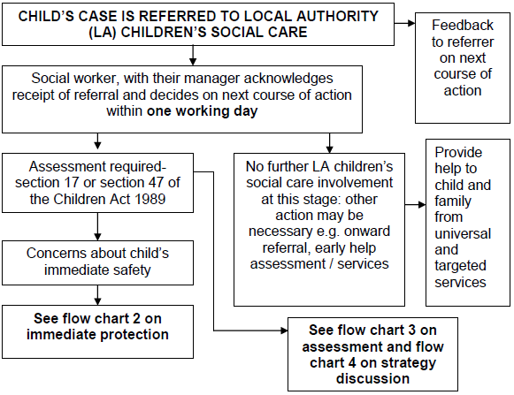

Flow chart 2: Immediate protection
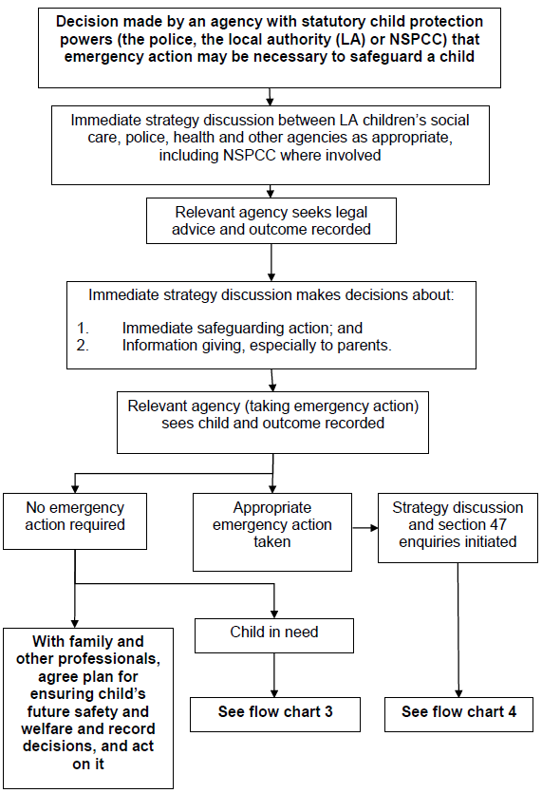

Flow chart 3: Action taken for an assessment of a child under the Children Act 1989
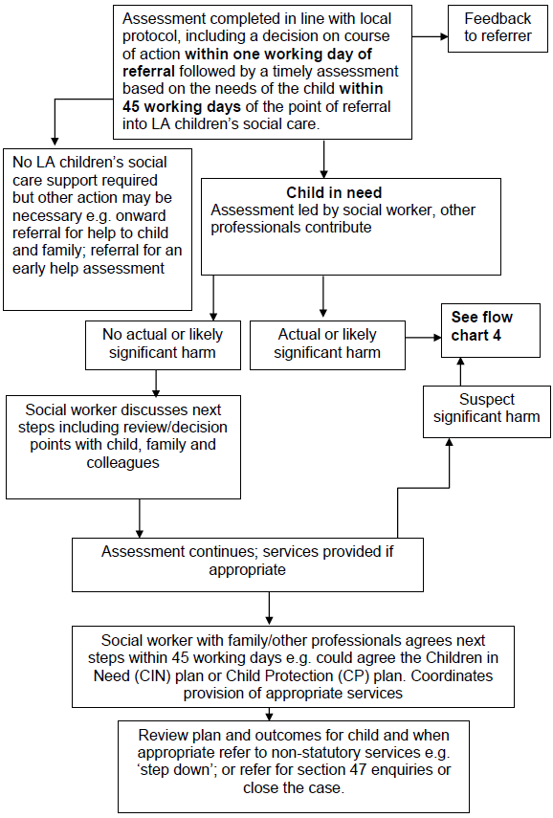

Flow chart 4: Action following a strategy discussion
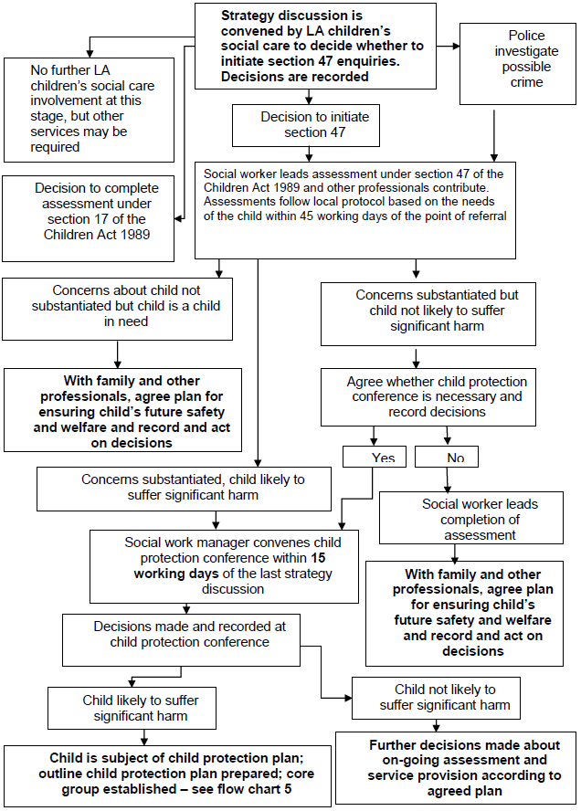
Appendix 3: Child Protection Internal Recording Pro Forma

CONFIDENTIAL
The following information

Full name, including any aliases.

Gender
Date of Birth
Address:
Who Has Parental Responsibility?
Details of disclosure or concern, include date, time, full names, actual wording used)

Any special needs of the child/ren.

Actions Required
Consent Given by child/young person/parent:
Yes / No

If consent not given, please state clearly reason for overruling the need for consent.

Follow Up

Your Name

Your Role

Signature

Date, time and place:

Our commitment to protecting children and young people is set out in our Safeguarding Policy.
Appendix 4: Body Map
This form can be used to note any areas of abuse you think may have occurred.

RECOGNITION OF POTENTIAL CHILD ABUSE (SKIN MAP)
DATE OF BIRTH
NAME OF YOUNG PERSON

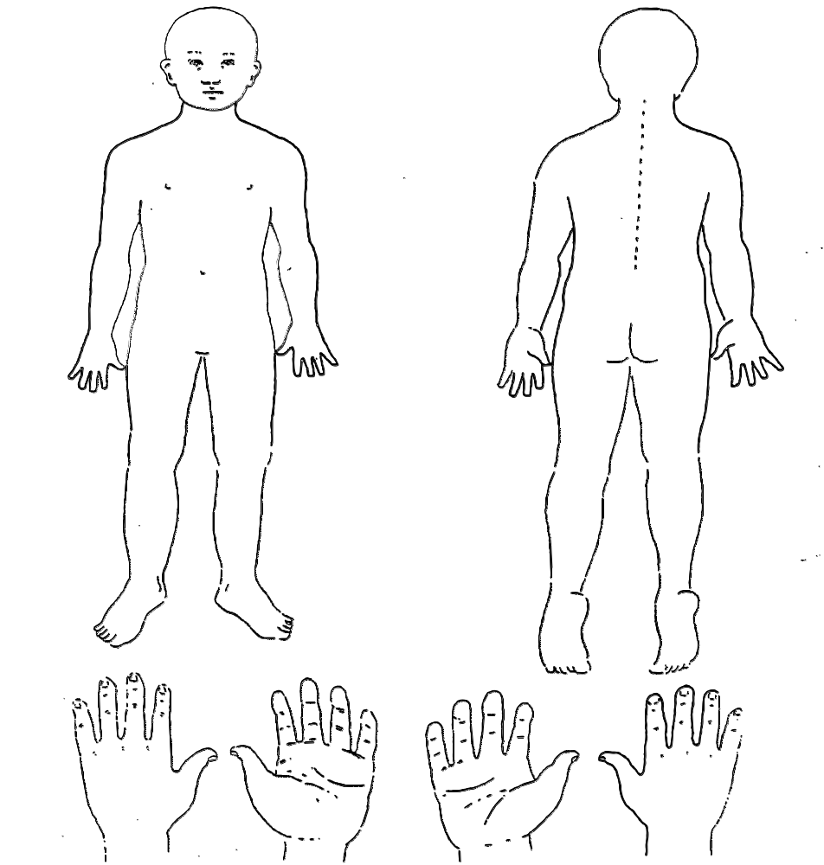

NAME OF REFERRER
SIGNATURE OF REFERRER
DATE

Appendix 5: Legal framework

(insert organisation name) works in accordance with local guidance from West Yorkshire Consortium Procedures Manual and statutory legislation based on law and guidance that seeks to protect children, namely;
- Children Act 1989
- Children Act 2004
- Children and Families Act 2014
- Children missing education (September 2016)
- Counter-terrorism and Security Act 2015 (section 26 Prevent duty)
- Data Protection Act 1998
- Disqualification under the Childcare Act 2006 (February 2015)
- Female Genital Mutilation (FGM) Act 2003 (as amended by Serious Crime Act 2015)
- Human Rights Act 1998
- Information sharing – Advice for safeguarding practitioners’ (March 2015)
- Prevent Duty 2015
- Protection of Freedoms Act 2012
- Safer working Practice Guidance (October 2015)
- Sexual Offences Act 2003; amended 2006
- Safeguarding Vulnerable Groups Act 2006
- Special Educational needs and disability (SEND) code of practice: 0 – 25 – Statutory guidance for organisations who work with and support children and young people who have special educational needs or disabilities; HM Government 2015
- United Convention of the Rights of the Child 1991
- What to do if you’re worried a child is being abused (March 2015)
- Working Together to Safeguard Children (2015)

